
NOVUS
Smart Editorial & Publishing Platform
AY 2025-2026

AUTHORS:
Rei Khalil S. Galido
INDIRECTLY AIDS:
CONTRIBUTES TO:
Roman Rico B. Albania
Joshmar L. Clavero

CO-AUTHOR:
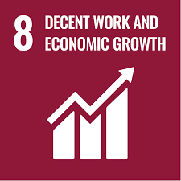



Felino Calderon III

Table of Contents
List of Figures iii
List of Tables iv
I. Introduction 5
A. Project Context 5
B. Statement of the Problem 5
C. Objectives 6
D. Significance of the Project 7
E. Scope and Limitations 7
II. Review of Related Literature / Systems 9
A. Editorial Workflow and Content Management Systems 9
B. Algorithmic Gating Justification Versus Commercial Text Editors 9
C. Digital Media Sustainability and Owned Platform Strategy 10
D. System Cost Consolidation and Polyglot Database Stability 10
E. Secure Notification Dynamics and Role-Based Entitlements 11
F. Algorithmic Calibration: Psycholinguistics, Readability, and Threshold Defense 11
G. Literature Synthesis and Identified Gaps 11
III. Current System 13
A. Technical Background 13
B. List of Processes 13
C. SWOT Analysis 14
IV. Proposed Solution 15
A. Technical Background 15
B. Feasibility 18
C. Requirements Analysis 19
V. Conclusion 35
References 36
Appendix A: Roles and Responsibilities 40
Appendix B: Minutes of the Meetings 41
Appendix C: Methodology 47
Appendix D: Project SharePoint Link 48
Appendix E: Requirements Traceability Matrix 49
Appendix F: RACI Matrix 50
Appendix G: Writer Survey Results 51
Appendix H: Editor Survey Results 58
Appendix I: Final Defense Comment Matrix 70
Appendix J: Brand Tone Survey Results 72
Appendix K: Midterm Comment Matrix 77
Appendix L: Statement of Work 79

List of Figures
Fig. 1. Flow 1 — Authentication 20
Fig. 2. Flow 2 — Writer Side 21
Fig. 3. Flow 3 — Editor Side 22
Fig. 4. Flow 4 — Graphic Designer Side 23
Fig. 5. Flow 5 — Publisher Side 24
Fig. 6. Flow 6 — Public Magazine Website 25
Fig. 7. Lean Canvas 26
Fig. 8. Use Case Diagram High Level 27

List of Tables
Table 1. List of Processes in the Current System of BOSS Media Philippines Inc. 13
Table 2. SWOT Analysis of BOSS Media Philippines Inc. 14
Table 3. Article Scoring Framework 15
Table 4. Computational Basis for Each Scoring Component 16
Table 5. User Classes 26
Table 6. Product Backlog 27
Table 7. Use Case Summary 33

I. INTRODUCTION
The media industry in the Philippines is undergoing a critical shift. As digital consumption grows and audiences increasingly move away from traditional print and social media-dependent distribution, independent publications face mounting pressure to modernize their operations or risk being left behind [1]. BOSS Media Philippines Inc., the client organization of this project, is one such publication — a Filipino media company producing content that spans local and international events, featured personalities, and cultural issues, yet operating today without any dedicated digital infrastructure to support its editorial, publishing, or revenue functions. All article assignments, submissions, reviews, revisions, and approvals are handled manually across personal messaging applications, with no system, no tracking, and no automation of any kind.

A. Project Context
BOSS Media Philippines Inc., publisher of BOSS Magazine, aims to scale into a globally recognized Filipino media brand with a sustainable digital revenue model. To achieve this, the organization is developing Novus, a dual-purpose platform designed to solve current operational bottlenecks and drive future growth.
Currently, the core production workflow between the Publisher, Editor, Writers, and Graphic Designer is highly fragmented. The team faces several critical challenges:
- Informal Channels: Assignments, submissions, and design files are routed through disjointed platforms like Messenger, Viber, and Gmail.
- Lack of Standardization: There are no formal design or editorial briefs, deadline tracking systems, or centralized review hubs.
- Zero Pipeline Visibility: The Publisher relies entirely on manual updates from the Editor and lacks real-time oversight of the production process.
Novus will directly address these issues by providing a centralized internal system to standardize the editorial pipeline, alongside a public-facing platform to expand audience reach and monetize their digital content.
"We need to start earning from what we publish. We cannot keep printing and posting for free. I want BOSS Magazine to look and feel like a professional international publication." — Editor/Publisher
B. Statement of the Problem
BOSS Magazine PH is a comprehensive Filipino lifestyle publication — covering a broad spectrum of topics including fashion, culture, modern trends, business, and society — that currently operates without any dedicated digital infrastructure to support its editorial, publishing, or revenue functions.
I. Fragmented Editorial Workflow and Inability to Scale
The first and most critical problem is the absence of a centralized editorial workflow system, which directly limits the magazine's ability to scale. The sole editor of BOSS Magazine PH manually manages 10 or more article submissions per publishing cycle, receiving drafts through 4 or more different communication platforms including Messenger, Viber, and email simultaneously. This results in 21 to 49 work-related messages per day, forces the editor to spend 31 to 40 hours per week on editorial tasks, and leaves no traceable record of submission history, revision rounds, or approval decisions. Furthermore, as the writer roster grows, this editorial workload grows proportionally with no additional support — resulting in cascade publishing delays where one late article pushes back the entire issue, and a publishing cycle that regularly exceeds 2 weeks to complete.
II. Time-Consuming Manual Content Reviews
The second problem is the lack of an automated content review mechanism. Every article submitted by a writer goes directly to the editor for a full manual review — covering grammar, spelling, tone, brand voice, and structure — before any feedback is given. Because there is no first-pass automated review tool, the editor spends more than 2 hours per day writing and explaining revision notes, and an additional 1 to 2 hours chasing writers for follow-ups and resubmissions. Only 3 to 4 out of every 10 submitted articles require no revision, meaning the majority of submissions add significant manual labor to an already overloaded workflow.
III. No Dedicated Digital Platform or Organic Reach
The third problem is the lack of a functional and reliable public digital presence. While BOSS Magazine PH previously attempted to establish a website using a third-party builder (Webtulz), the platform proved unviable, difficult to maintain, and is currently non-functional. As a result, the magazine has been forced to revert to publishing exclusively through Facebook. This limits the magazine's reach to existing social media algorithms, provides no mechanism to attract new readership organically through search engines, and prevents the publication from being taken seriously as a professional media entity by brand partners or international audiences.
IV. Zero Direct Revenue Generation
The fourth problem is the complete absence of a revenue model. Despite producing consistent editorial content, BOSS Magazine PH generates zero direct revenue from its published output. There is no subscription system, no digital issue sales mechanism, and no paywall — meaning the magazine bears the full operational cost of production with no financial return from its readership.
C. Objectives
Main Objective
To develop Novus — a web-based editorial platform and publishing system with AI features — for BOSS Magazine PH. The system will centralize the editorial workflow, automate first-pass article reviews, launch a professional digital website, and generate subscription revenue to help the magazine become a self-sustaining business.
Specific Objectives
To ensure the system's operational success and feasibility, the development of Novus is guided by the following measurable targets:
- Workflow & Capacity: To streamline the editorial process of BOSS Magazine PH by implementing a centralized pipeline system that can handle a minimum of 50 article submissions per month, ensuring all updates and progress are tracked and visible to the team in one place.
- Workload Reduction: To reduce the time editors spend reviewing each article from an average of 45 minutes to approximately 20 minutes through the use of an AI-assisted pre-screening feature.
- Portal Performance: To develop a reader-facing website for BOSS Magazine PH that is fast, accessible, and available in both English and Filipino, meeting standard web performance benchmarks upon launch achieving a good rating having an average of 85 across its core evaluation metrics
- Monetization & Transactions: To enable digital purchasing of magazine content through the system by supporting local e-wallet and international card payments, validated through successful test transactions before going live.
D. Significance of the Project
Primary Beneficiaries
The implementation of Novus directly benefits the core production team and its audience. For the editor, AI-assisted reviews and a centralized dashboard eliminate hours of manual administration, allowing a shift toward high-value strategic editing. The publisher gains real-time pipeline visibility and enforces deadlines while unlocking a critical digital revenue model through subscriptions and sales. Writers transition from fragmented chat handoffs to a dedicated portal, where instant AI feedback on grammar and tone significantly accelerates the revision cycle. Finally, readers benefit from a professional standalone website that offers premium subscriptions, digital purchases, and an interactive AI agent for personalized content discovery.
Improvement to the Current Situation
Novus drastically improves the magazine's current operational, editorial, commercial, and reputational standing. Operationally, it replaces a delayed, manual publishing cycle with a structured, trackable workflow. Editorially, automated AI pre-checks raise the baseline quality of submissions, drastically reducing manual revision rounds. Commercially, the platform transforms a zero-revenue operation into a monetized business with active subscriptions and digital storefronts. Ultimately, Novus elevates BOSS Magazine PH from a social media presence to an authoritative, professional digital publication.
Sustainable Development Goal (SDG) Alignment
SDG 8 — Decent Work and Economic Growth. Novus directly contributes to SDG 8 by enabling BOSS Magazine PH to build a sustainable digital business model that supports the livelihoods of its editorial team, writers, and publisher. By introducing a subscription-based revenue stream, the platform creates a foundation for the magazine to compensate its contributors fairly and grow as a viable media enterprise. Additionally, by reducing the editor's unsustainable 31–40-hour editorial workload through automation, Novus promotes healthier and more equitable working conditions within the organization.
SDG 9 — Industry, Innovation, and Infrastructure. Novus also aligns with SDG 9 by building the digital infrastructure that BOSS Magazine PH currently lacks — transforming an informal, chat-based operation into a technology-enabled publishing system. The integration of AI-assisted editorial review and a reader-facing AI engagement agent represents a direct application of innovation to a real industry challenge, demonstrating how small independent publishers in the Philippines can leverage modern technology to operate at a level previously only accessible to large media organizations.
E. Scope and Limitations
Scope of the Project
The scope of Novus encompasses a comprehensive, role-based platform designed to manage the entire editorial and publication lifecycle. It features a dedicated writer portal with an integrated AI-assisted review system that automatically evaluates submissions for grammar, brand alignment, and SEO. This feeds into a centralized editorial dashboard equipped with structured revision management and approval workflows, effectively eliminating the need for external chat applications. For public engagement and monetization, the platform includes a bilingual (English and Filipino) web interface featuring an interactive AI discovery agent, alongside a flexible global payment architecture to handle digital subscriptions and individual issue sales. Additionally, an admin dashboard provides high-level analytics on production workflows and revenue metrics.
Limitations of the Project
Despite its broad functionality, the current iteration of Novus has clear boundaries. It is exclusively a web-based application without native mobile apps, offline functionality, or integration with external content management systems. Within the editorial process, it lacks real-time collaborative editing and advanced detection for AI-generated submissions. Furthermore, the system does not handle physical print management, social media auto-publishing, or advertising inventory tracking. Currently restricted to English and Filipino, these functional and linguistic constraints are acknowledged as deliberate boundaries for the initial release, serving as opportunities for future expansion as the publication scales.

II. REVIEW OF RELATED LITERATURE / SYSTEMS
This chapter reviews the foundational research, industrial benchmarks, and system architectures relevant to the deployment of Novus: Smart Editorial and Publishing Platform. To satisfy the rigorous technical requirements of systems evaluation and explicitly address baseline defensibility, this review synthesizes overlapping academic and industrial sources. This comprehensive evaluation establishes the empirical basis for the core engineering milestones, validates the machine learning integrations, and contrasts the unified software architecture against disjointed consumer-grade alternatives
A. Editorial Workflow and Content Management Systems
The baseline metrics defining the Novus content pipelines—specifically the target to process a scalable minimum of 50 articles per month and reduce manual review times from an average of 45 minutes down to 20 minutes—are systematically derived from documented newsroom efficiency trends. Analysis by CFlow demonstrates that unstructured content operations experience a 30% drop in absolute productivity when coordination relies on fragmented communication mediums, confirming that 68% of media teams experience severe operational bottlenecks due to a lack of centralized pipeline visibility [2]. However, when automated pipeline management environments are formally implemented, content turnaround times are systematically compressed by up to 50% [2]. Partida further demonstrates that smaller, independent publishing houses frequently suffer from systemic delays because they adopt general-purpose, single-user drafting environments—such as personal messaging accounts and loose word processors—that inherently fail to manage multi-role editorial states [3]. The PubLink framework resolves these tracking deficiencies by processing digital manuscripts as structured objects characterized by explicit metadata states and immutable workflow transitions, ensuring that the migration of content from draft submission to final layout approval is secure, fully auditable, and traceably isolated from standard consumer chat noise [4]. Furthermore, Brechner and Cervone evaluate the cognitive overhead induced when content teams partition their focus across distinct software suites, indicating that visualizing operational streams through an integrated Kanban-style interface independently reduces operational cycle times by 24% [5], [6]. This significant reduction is achieved entirely by eliminating the mental friction associated with tracking manuscript statuses across disparate environments.

B. Algorithmic Gating Justification Versus Commercial Text Editors
A primary architectural distinction of Novus is the structural justification for building a proprietary, platform-native first-pass review engine rather than relying on standard commercial extensions like Grammarly. Standard consumer writing utilities operate strictly as localized, single-user text extensions; they are fundamentally incapable of altering application-wide database routing states, lack role-based execution parameters, and cannot trigger downstream workflow notifications across an organizational infrastructure. As documented by Arifin et al., true newsroom optimization demands a layered architecture that pairs automated language evaluation directly with role-based document transitions [7]. Research by Srivastava and Singh confirms that deploying automated manuscript screening at the point of ingestion yields accelerated review velocities by filtering out structurally deficient text before a human editor dedicates manual focus to it [8]. Hurley, Mayew, and Stephan verify that automating baseline compliance checking is a modern operational prerequisite for media organizations aiming to match digital distribution speeds [9]. To execute this, Novus plans to utilize Google Gemini for its core editorial inference tasks, supported by Dwivedi et al., who confirm that contemporary large language models execute complex multi-step semantic analyses with an accuracy profile matching professional human evaluators when configured within structured prompt environments [10]. While traditional grammar tools evaluate syntax on a superficial sentence-by-sentence level, advanced generative engines offer deep semantic comprehension, allowing the platform to perform continuous contextual analysis, verify tonal alignment, map structural gaps across an entire text layout, and append actionable inline annotations directly within the document database prior to human review.

C. Digital Media Sustainability and Owned Platform Strategy
Transitioning small independent publishers away from volatile third-party social networking distribution networks is a critical requirement for long-term viability. Audience analysis metrics indicate that user reliance on mainstream social network news algorithms has degraded significantly, experiencing drops of up to 11 points in key demographics [11]. This paradigm shift forces independent digital media entities to establish standalone web applications to maintain organic search discovery and directly engage their readership. Industrial economic reporting from Deployteq establishes that 80% of publishers globally are prioritizing reader-supported subscription models as their primary revenue framework, heavily exemplified by prominent modern publications that derive over 60% of total operational profits purely from gated subscription structures [12]. In emerging digital economies such as the Philippines, transaction execution drop-off rates increase dramatically when localized digital wallet architectures are missing from user checkouts. Oliveira et al. demonstrate that ensuring direct native access to prevailing regional payment methods—validating the integration of platforms like PayMongo—is vital for maximizing financial conversion behaviors [13]. Furthermore, Radu verifies that content platforms integrating automated billing engines retain consumer subscriptions at rates 34% higher than operations utilizing manual invoicing or external transaction links [14]. This retention performance occurs because automated billing systems significantly lower user execution effort, a factor that Hamari, Hanner, and Koivisto identify as the single most critical driver governing freemium subscription renewals [15].

D. System Cost Consolidation and Polyglot Database Stability
To mitigate cost and structural complexity while targeting a strict Google Lighthouse Performance score of 90 or above, the architecture of Novus consolidates operations into a streamlined, polyglot cloud database configuration within a unified Platform-as-a-Service (PaaS) network. Jamshidi et al. confirm that co-locating computational engines and persistent database environments within a single cloud provider’s private network infrastructure eliminates cross-provider network hops [16]. This architectural design minimizes API response times and prevents the unbounded multi-provider data egress cost accumulation that typically inflates startup expenses. Fowler and Sadalage establish that forcing heterogeneous data types into a singular relational structure causes immediate performance bottlenecks and schema rigidities, dictating that content applications require a partitioned persistence strategy tailored carefully to distinct transaction workloads [17]. The relational layer, implemented via PostgreSQL, satisfies the strict ACID compliance requirements established by Gray and Reuter as mandatory for user permissions, billing states, and core transactional financial events [18]. Cloud Firestore provides live client-server synchronization, enabling the sub-second latency required for operational workflows as validated by Tudorica and Bucur [19]. Crucially, Davoudian, Chen, and Liu verify that high-throughput system logging and background data processing operations consistently degrade public reader query performance when shared across a singular data instance [20]. By isolating append-heavy metadata processes and AI prompt histories into a dedicated MongoDB NoSQL layer, the system eliminates write-amplification delays, mathematically securing the high-speed frontend query execution necessary to hit the 90+ Lighthouse performance target.

E. Secure Notification Dynamics and Role-Based Entitlements
Multi-user media systems require explicit system isolation to prevent privilege escalation and communication breakdown across user classes. Caivano et al. evaluate collaborative workflow speeds and prove that teams deploying real-time browser push notifications complete multi-stage approval pipelines 43% faster than teams dependent exclusively on email channels [21]. However, Mehta and Rozanski state that mixing internal operational status updates with external reader notifications induces widespread notification fatigue and degrades systemic presentation standards [22]. Novus implements a dual-channel separation framework, isolating internal Firebase Cloud Messaging (FCM) operations from server-side transactional email execution routines to resolve this conflict. Saltzer and Schroeder establish that routing all core system notification triggers through secure server-side environments is mandatory to prevent external manipulation of transactional records, a design constraint achieved by anchoring user authorization to secure session tokens [23]. Basin, Clavel, and Egea further demonstrate that declarative security rules implemented natively at the storage tier represent the most resilient defense against interface manipulation [24]. Because these rules are evaluated directly at the database engine level, unauthorized clients cannot bypass platform constraints, ensuring total role separation across the application's workspace environments.

F. Algorithmic Calibration: Psycholinguistics, Readability, and Threshold Defense
To prove that the automated first-pass screening framework is scientifically grounded rather than arbitrary; its evaluation metrics are explicitly derived from established readability formulas and psycholinguistic research. The engine evaluates content using a strict 60/40 weighted matrix with an unyielding 75% passing threshold. The dominant 60% weight allocated to grammatical accuracy acts as a defensive brand measure. Pitler and Nenkova demonstrate that human readers process typos and mechanical syntax breakdowns through fast, subconscious cognitive reflexes that instantly trigger negative author assessment and destroy a publication's perceived credibility [25]. Because grammar compliance is inherently objective, it can be mathematically quantified with high confidence, ensuring that poorly proofread drafts are rejected immediately. Conversely, the 40% readability allocation acts as a critical optimization defense against gradual reader abandonment. As established by Dale and Chall, modern digital audiences primarily scan text patterns, and content that routinely forces readers to exceed standard cognitive memory limits results in page abandonment [26]. Novus incorporates the Flesch Reading Ease calculation to guarantee text tracks tightly within a target 60 to 70 range, optimizing content for digital reader consumption without altering semantic intent. The mathematical decision to set the passing threshold at exactly 75% reflects established data within Automated Essay Evaluation structures. Koppel, Schler, and Argamon verify that professional human editors evaluating complex article narrative standards exhibit an inter-rater reliability agreement rate varying between 75% and 80% [27]. Forcing the platform baseline above 80% introduces severe algorithmic rigidity, causing the system to falsely reject creative formatting or advanced narrative journalism. Conversely, setting the threshold lower than 75% allows text to pass even if it completely fails one of the core quality pillars. To account for high-quality writing that relies on deliberate colloquialisms or stylistic non-compliance, the platform integrates a Human-in-the-Loop (HITL) bypass mechanism, allowing authorized editors to manually override a low AI score, thereby protecting human editorial control and continuously refining the machine learning prompt criteria.

G. Literature Synthesis and Identified Gaps
The synthesized literature review proves that the technical milestones governing Novus are thoroughly grounded in established academic and industrial models. Editorial workflow research proves that automated pre-gating pipelines consistently eliminate operational delays and optimize newsroom timelines. Architecture literature confirms that private Platform-as-a-Service environments and polyglot database isolation maximize performance while stabilizing startup costs. Finally, psycholinguistic data validates the mathematical thresholds used to run automated quality screening without causing system rigidity. The critical gap identified across the literature is the total lack of integrated, low-cost platform environments built specifically for independent publishers in developing digital media markets. Existing enterprise systems require massive engineering resource footprints and high licensing costs, while basic text plugins fail to provide pipeline workflow management, platform data persistence, or consumer payment integration. Novus directly addresses this vacuum, providing an all-in-one editorial management ecosystem that bridges automated manuscript verification with an integrated reader marketplace.

III. CURRENT SYSTEM
A. Technical Background
The current system of BOSS Media Philippines Inc. operates entirely without dedicated software or digital infrastructure. All editorial and publishing processes are carried out through a combination of consumer-grade communication applications and general-purpose productivity tools. The primary platforms in use include Facebook Messenger, Viber, WhatsApp, Gmail, and Google Docs, which serve simultaneously as briefing channels, submission inboxes, revision communication tools, and publication coordinators. No editorial management software, content management system, project tracking tool, or publishing platform has been formally implemented.
In terms of hardware, the team operates using personal computers and mobile devices owned by individual staff members and writers. There is no shared server, internal network, or cloud workspace dedicated to editorial operations. File storage and version control are handled informally through Google Drive folders and shared Google Docs links, with no naming convention, folder structure, or access control policy in place.
The graphic designer works using Canva and other design applications on personal devices, with no shared design system or file handoff protocol. The publisher manages the physical printing and social media distribution manually, coordinating through the same consumer messaging platforms used throughout the rest of the workflow.
B. List of Processes
Table 1 lists all current processes in the editorial and publishing workflow of BOSS Media Philippines Inc. Each process is identified by a unique process ID, a process name, and a description of how the process is currently performed. These processes were documented through direct data gathering with the Editor and Publisher and validated through the writer survey conducted in March 2026.
TABLE I.
List of Processes in the Current System of BOSS Media Philippines Inc.
Process ID | Process Name | Process Details
P001 | Topic Assignment | The Editor assigns a topic or story angle to a Writer through Facebook Messenger, Viber, Gmail, or a verbal conversation. No standardized brief template or deadline system is used.
P002 | Article Writing | The Writer drafts the article using Google Docs or a notes application. The Writer determines formatting independently as no writing guide is provided.
P003 | Article Submission | The Writer submits the completed article through the same fragmented communication channels used for the assignment. No centralized submission portal exists.
P004 | Editorial Review | The Editor manually reviews the submitted article for grammar, tone, structure, and brand alignment. This takes one to two days per article, with 61 to 80 percent of submissions requiring at least one revision.
P005 | Feedback & Revision | The Editor sends revision notes through private messaging. The Writer revises and resubmits within three to five days on average. This loop repeats for two to three rounds per article.
P006 | Article Approval | The Editor approves the final version and informs the Writer through chat. Only three to four out of every ten articles are approved on the first submission.
P007 | Layout Production | Approved articles are forwarded to the Graphic Designer through chat or email. The Designer arranges the magazine layout with no formal design brief or file-sharing system.
P008 | Layout Review | The completed layout is sent back to the Editor for a final check. Revision notes are relayed again through informal messaging.
P009 | Publishing | Once the layout is confirmed, the Publisher receives the final files and manually publishes the issue to social media platforms and coordinates physical printing. No publishing schedule system is used.
C. SWOT Analysis
The SWOT analysis below evaluates the internal strengths and weaknesses of BOSS Media Philippines Inc. as an organization, as well as the external opportunities and threats it faces in the current Philippine media landscape. Each point is derived from the data gathering conducted with the editorial team and from the broader industry context established in the literature review.
TABLE II.
SWOT Analysis of BOSS Media Philippines Inc.
Strengths | Weaknesses
• Established publication identity with a Filipino-focused editorial voice and brand  • Dedicated and committed core team willing to improve the current workflow  • Existing readership base on Facebook and Instagram  • Content covers a broad range of topics increasing discoverability potential | • No centralized editorial workflow or project tracking system in place  • Single editor handling 10+ articles per cycle with no automation support  • 61–80% of articles require revision; only 3–4 out of 10 are approved on first submission  • Zero direct revenue generation from published content  • No formal publishing schedule; delays regularly exceed 2 weeks
Opportunities | Threats
• Filipino Facebook news reliance dropped 11 points in 2024, creating demand for owned platforms (Newman et al., 2024)  • 80% of publishers globally are investing in subscription models as a primary revenue stream (Deployteq, 2024)  • Commercial LLM APIs now make AI-assisted editorial review accessible to small publications  • Growing Filipino internet penetration and mobile-first consumption opens wider digital audiences | • Continued reliance on Facebook risks further reach reduction as algorithm changes deprioritize media content  • Growing competition from digital-native Filipino media brands with existing platforms and revenue models  • AI-generated content flooding the media space raises audience trust concerns across all publications  • Operational burnout risk — single editor handling a growing workload with no system support

IV. PROPOSED SOLUTION
A. Technical Background
Novus is a cloud-native editorial management system deployed on a unified platform-as-a-service (PaaS) environment. To minimize architectural complexity and infrastructure costs, the system refactors traditional polyglot environments into a single, consolidated relational database. This unified database instance handles strict transactional data (user roles and billing), manages active article document states, and safely stores append-heavy audit logs utilizing native text-field features, eliminating the need for multiple external database platforms. The editorial dashboard and public magazine portal are served through a modern web frontend framework, requiring no local software installation or on-site IT maintenance.
Core System Features
- Visual Pipeline Tracking: Novus centralizes editorial workflow management through a Kanban-based pipeline dashboard, replacing fragmented communication channels. Article submissions progress through defined stages—from submission through review to publication—providing all authorized personnel with centralized visibility into every article's status.
- Unified AI-Powered Editorial Assistant: Prior to editorial review, every submission undergoes an automated evaluation. To optimize token usage and minimize API latency, the system utilizes a single, high-tier generative language model API. This AI is restricted to a single structured data execution (JSON format) to simultaneously evaluate grammatical accuracy and extract contextual editorial briefs, completely removing the need for secondary language models.
- Targeted Notification Protocol: External transactional communications, deadline reminders, and critical workflow state transitions are dispatched exclusively through a server-side, API-driven email service. This single-channel approach eliminates the need for complex browser push notification engines, reducing system dependency while preventing notification fatigue.
- Streamlined Payment Infrastructure: Novus integrates a single, localized payment gateway provider dedicated to domestic electronic wallet transactions and local cards. This architecture eliminates the development overhead of managing secondary international payment processors while directly capturing the publication's primary domestic market.

First Pass Review: Scoring Framework (Writer Side)
Each submitted article undergoes an automated first-pass review producing a composite Readability and grammar that is graded 0 out of 100, ensuring Editors engage only with submissions that meet a defined minimum quality threshold.

TABLE III.
Article Scoring Framework
Category | Weight | Description
Readability | 40% | Mathematical calculation based on average sentence length and syllable count per word.
Grammar | 60% | Evaluates grammatical accuracy of the submission
Total | 100%

Passing Threshold: A minimum composite score of 75% is required for a submission to advance to the editorial review stage. Submissions falling below this threshold are automatically returned to the Writer for revision
TABLE IV.
Computational Basis for Each Scoring Component
Component | Explanation
Readability — Flesch Reading Ease | Evaluates how effortlessly a digital audience can consume the article by measuring sentence length and syllable density. Rather than focusing on complex mathematical formulas, this metric practically ensures the writing hits the industry-standard "Plain English" zone. It targets a score between 60 and 70, which translates directly to an 8th to 9th-grade reading level—the proven sweet spot for keeping digital readers engaged without causing cognitive fatigue or page abandonment.
Grammar Penalty | A flat deduction of 5 points is applied to the Grammar component for each error identified, ensuring the score degrades proportionally with submission quality.

Human-in-the-Loop (HITL) Override Mechanism
To address the limitations of automated evaluation, the system incorporates a Human-in-the-Loop (HITL) override mechanism. Because mathematical formulas lack the contextual awareness to recognize intentional stylistic choices—such as deliberate colloquialisms that might artificially lower a score—the algorithm is designed to never overrule human judgment on edge cases. Authorized editors can manually bypass a failing grade and advance a manuscript directly into the review pipeline. This not only preserves absolute editorial authority but also provides valuable system feedback. By tracking how often articles are manually bypassed, developers can continuously refine the automated grading criteria to better reflect the publication's actual standards.

Contextual Narrative Analysis (Editor's Side)
If a submission passes the first pass review from the writer’s side (or receives a HITL override), it automatically advances to the "Ready Review" stage within the Kanban dashboard. Because the basic formatting, grammar, and brand alignment have already been validated, the system (AI) silently triggers a secondary background evaluation focused on the evaluation of the article as a whole and will present the results to the editor.

This phase does not assign a numerical score or act as a gatekeeper like the first pass review from the writer's side. Instead, it acts as a collaborative assistant, generating a private Editor's Brief from the AI, attached directly to the article’s record. This brief is visible only to users with Editor or Publisher privileges and evaluates the article across three narrative pillars:

- The Hook and Reader Engagement: The model evaluates the opening paragraphs to determine if the main point is buried. It analyzes whether the introduction effectively sets the stakes of the article and gives the target audience a compelling reason to keep reading.
- Story Flow and Logic: The system traces the underlying structure of the article, identifying sudden jumps in the timeline, missing background information, or weak transitions between paragraphs that might confuse a reader.
- Targeted Content Extraction: To help the rest of the team work faster, the AI pulls out two specific pieces of text:
  - The Marketing Highlight: It finds the most impactful, standalone sentence to be handed off to the Graphics Designer or social media team for promotional quotes.
  - The Editorial Bottleneck: It flags the single most confusing or poorly structured paragraph, showing the human editor exactly where their manual rewriting skills are most needed.

Change Management and User Training
Introducing a new system to an existing team requires more than just building the software. To ensure the editorial team actually adopts and uses Novus effectively, the following steps will be taken:
- Onboarding Session — A live walkthrough demonstration for all writers, editors, and staff so everyone understands how to navigate the dashboard from day one.
- Digital Handbook — A reference guide covering submission formats, how to read the Brand Alignment Score, and what to do when an article is sent back for revision.
- Pilot Phase — Before fully switching over, the team will run Novus alongside their existing workflow for at least an issue. This gives everyone time to get comfortable without the pressure of a hard cutover.

Evidence Collection
To rigorously prove that the platform achieves its operational, financial, and technical objectives, the evaluation methodology has been expanded into a multi-tiered validation framework. During the pilot and testing phases, the following data points and performance indicators will be systematically collected to justify the system's success:
- Time-in-Status and Productivity Tracking: The system automatically logs the chronological duration each article spends at every stage of the editorial pipeline. This metric quantifies the exact reduction in editorial review time (targeting the drop from the 45-minute baseline) and measures the total throughput of articles published per cycle, directly providing objective data on how the platform scales newsroom productivity.
- Training Effectiveness and Change Management Validation: To ensure seamless system adoption, a comprehensive User Manual and digital onboarding protocol will be deployed to all writers and editors prior to testing. System validation will track user error rates (e.g., formatting submission errors or misunderstood revision loops) post-training to prove that the staff has successfully adapted to the new workflow and that the training materials are effective.
- Automated Override Rate and First-Pass Efficacy: The database will track the exact frequency at which human editors utilize the Human-in-the-Loop (HITL) override against the automated grading baseline. A low override rate, coupled with a measurable increase in articles passing the first review without manual revision (improving upon the legacy baseline where only 3 to 4 out of 10 articles were approved immediately), will mathematically prove the pre-screening algorithm is accurately calibrated and highly effective.
- System Usability and Cognitive Load Analysis: Beyond quantitative processing speed, standardized usability and cognitive load surveys will be administered to the editorial team post-pilot. This qualitative data will verify whether the centralized dashboard successfully eliminated the mental fatigue and stress previously caused by tracking submissions across multiple disjointed consumer messaging applications.
- Revenue vs. Infrastructure Cost Analysis: The administrative dashboard will actively track incoming subscription revenue generated through the integrated payment gateways against the unified cloud hosting and language model API operational costs. This financial tracing definitively proves the platform's economic feasibility and commercial sustainability for the client.
- Technical Performance and Accessibility Audits: To validate the reader-facing architecture, automated testing environments will execute standardized web performance audits during deployment. These audits provide objective, system-generated proof that the portal strictly achieves the high-performance, SEO, and accessibility benchmarks mandated in the project objectives.

Peopleware
The system utilizes Role-Based Workspaces to support six strictly defined user roles: Publisher, Editor, Writer, Graphics Designer, Reader, and Subscriber. Designed with an intuitive, browser-based interface, it requires no specialized IT personnel for client-side operation. The development of Novus is distributed across three academic terms — MNTSDEV for system design and requirements, MSYSADD for system modeling and documentation, and MCSPROJ for coding, integration testing, and deployment.
B. Feasibility
Operational Feasibility
Novus natively maps existing organizational roles into isolated workspace environments. The streamlined AI infrastructure automates the first pass of editorial review, targeting a reduction in manual workload to 20 minutes per article. The integration of a formal Change Management protocol (virtual onboarding, user manuals, and dual-run pilots) ensures high ease-of-adoption. Final publication authority remains strictly with human editors through the HITL override mechanism, preventing automated system bottlenecks during stylistic edge cases.
Economic Feasibility
The refactored architecture drastically reduces infrastructure overhead. By abandoning a multi-database approach and standardizing on a single relational database instance, the system entirely eliminates cross-database network egress fees and complex synchronization maintenance. Consolidating all machine learning tasks into a single language model API call utilizes minimal tokens, keeping operational expenses near-zero. The strategic decision to use only one localized payment gateway reduces platform transaction fees and API complexity, ensuring the platform remains highly profitable as subscriber counts scale.
Technical Feasibility
The platform directly limits its external dependencies to guarantee stability. AI hallucination is mitigated by anchoring the readability evaluations to deterministic mathematical backend formulas rather than generative language processing, enforcing strict schema outputs. By removing external enterprise logging suites and complex browser notification layers, the unified system simplifies long-term IT management, rendering it highly viable for development and deployment within the allotted academic timeframe.
Schedule Feasibility
The development of Novus is strategically phased across three academic terms under the Project-Based Learning curriculum, ensuring a modular and low-risk delivery:
- Phase 1 (MNTSDEV): Focuses on system design, requirement elicitation, and the development of the initial high-fidelity prototypes for the editorial dashboard.
- Phase 2 (MSYSADD): Dedicated to technical modeling, including UML diagrams and the architecture of the RAG pipeline and unified database schema.
- Phase 3 (MCSPROJ): Encompasses the final coding phase, unified API integration, rigorous system testing, and deployment to the production environment.

C. Requirements Analysis
Project Vision
The vision for Novus is to democratize professional-grade editorial infrastructure for independent publishers worldwide, transforming fragmented content production into a streamlined, high-output operation. By centralizing the editorial pipeline — from initial assignment to final approval — Novus aims to eliminate the administrative friction that typically stifles small-to-medium media houses. Through the integration of AI-assisted review systems, the platform empowers editorial teams to maintain rigorous standards without the need for massive human headcount, ensuring that even the smallest publications can produce polished, SEO-optimized content at the speed of modern digital discourse.

Beyond operational efficiency, Novus envisions a future where creators reclaim control over their financial destiny through owned platforms and direct reader engagement. The mission is to move publishing away from total reliance on social media algorithms and toward a sustainable 'freemium' ecosystem that converts passive scrollers into invested subscribers. By providing built-in, secure hybrid payment architectures and interactive AI discovery tools, Novus equips publishers with the professional digital presence and monetization strategies required to turn a labor of love into a profitable international brand, ensuring the long-term survival and independence of diverse voices in the global media landscape.

Prototype (Mock Flow / Wireframe)
The following figures present the low-fidelity wireframes for Novus, BOSS Magazine PH's proposed editorial workflow system. The prototype covers seven user flows across 24 screens, spanning five role types: Writer, Editor, Graphic Designer, Publisher, and Reader.
Figure 1 shows the entry point for all Novus users. Screen 01 presents a login form with a role-selector row (Writer, Editor, Publisher, Designer, Reader), directing each user to their appropriate workspace upon sign-in. Screen 02 displays a redirect loader that confirms the user's role and navigates them to their dashboard.

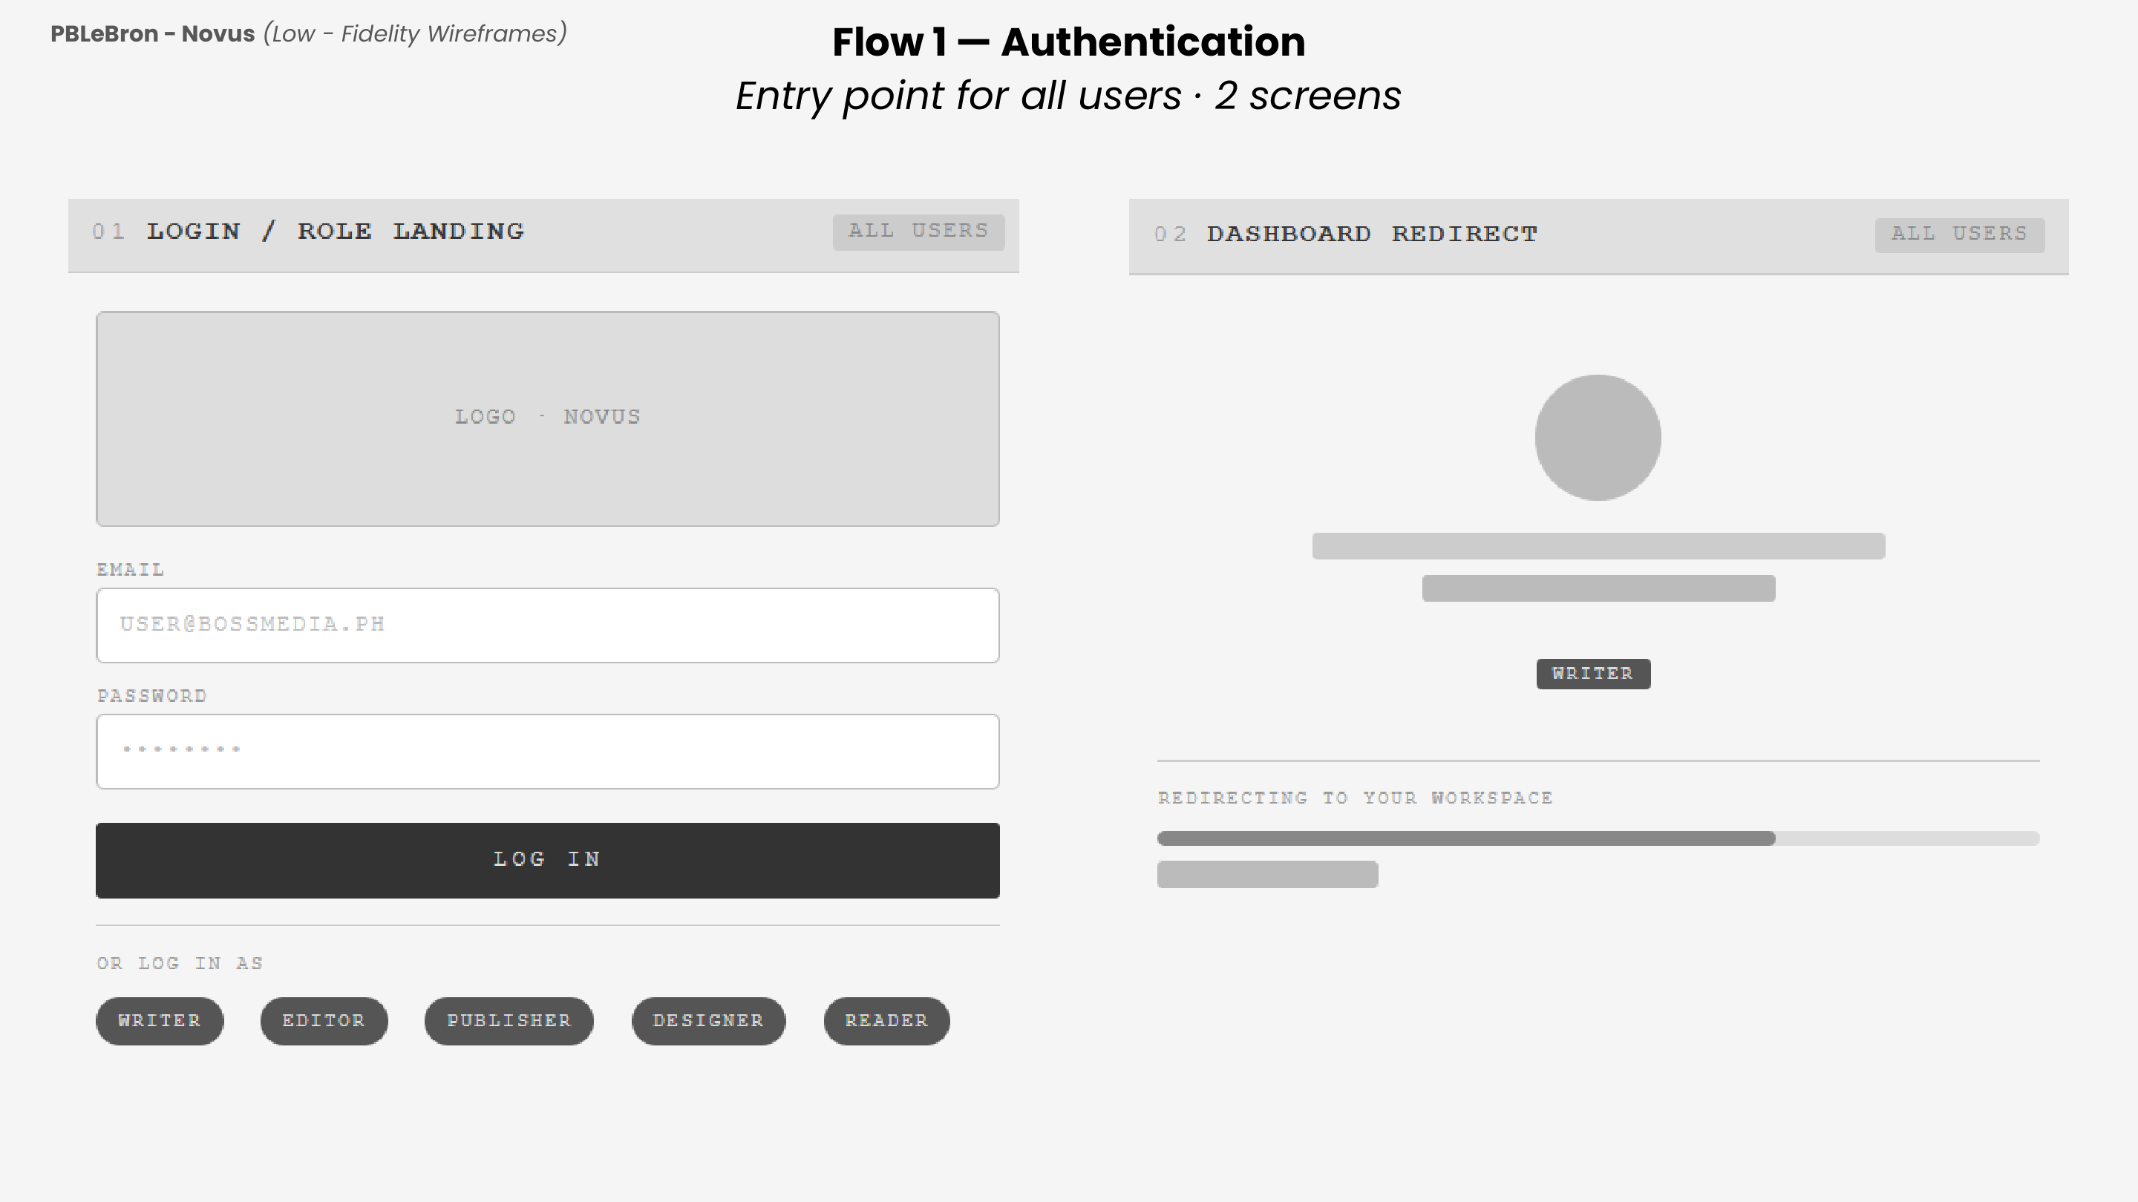Fig. 1. Flow 1 — Authentication. Login/Role Landing (01) and Dashboard Redirect (02).

Figure 2 covers the full writer workflow. The Writer Dashboard (03) displays active, revision, and approved counts with a task list. The Submission Form (04) collects the article title, category, word count, and body text. Upon submission, the AI Pre-Screen Result (05) auto-generates a Brand Alignment Score with grammar, tone, and structure indicators. The Submission Status View (06) tracks pipeline progress from submission to publishing. The Revision Notes Inbox (07) presents editor feedback by paragraph, allowing the writer to revise and resubmit.
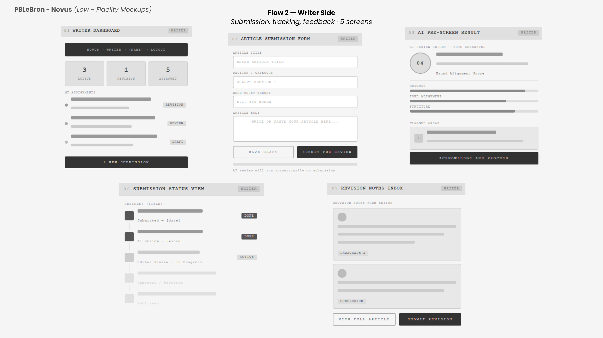
Fig. 2. Flow 2 — Writer Side. Writer Dashboard (03), Article Submission Form (04), AI Pre-Screen Result (05), Submission Status View (06), and Revision Notes Inbox (07).

Figure 3 details the editor's workspace. The Editor Dashboard (08) shows queue, revision, and approved counts alongside AI-scored submissions. The Article Review Screen (09) presents article content with AI scores and options to approve or request revision. The Revision Note Composer (10) lets the editor send categorized, prioritized feedback directly to the writer. The Approval Screen (11) confirms final sign-off and shows the evaluation of the AI on the weak and strong points of the article before forwarding to the publisher. Screens 12 and 13 handle deadline tracking and full-issue pipeline visibility.
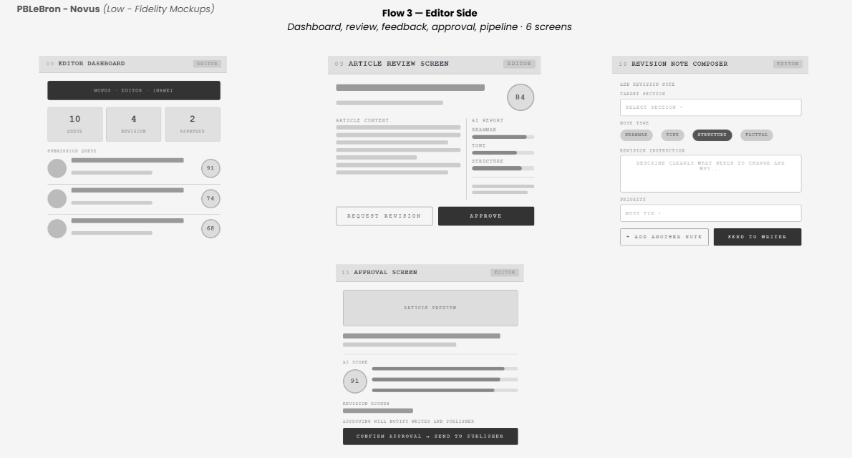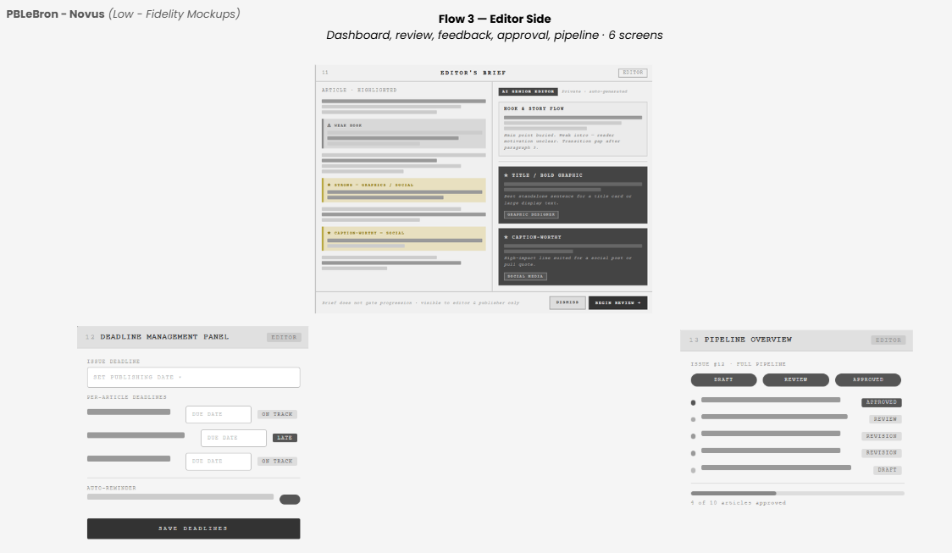Fig. 3. Flow 3 — Editor Side. Editor Dashboard (08), Article Review (09), Revision Note Composer (10), Approval Screen and Editor’s Brief (11), Deadline Management (12), and Pipeline Overview (13).
Figure 4 illustrates the designer's two-screen workflow. The Layout Handoff Screen (14) lists editor-approved articles with associated photo counts and download links for final content files. The Layout Submission Screen (15) allows the designer to upload a completed PDF or InDesign file, specify the layout version, and add notes before submitting for editor review.
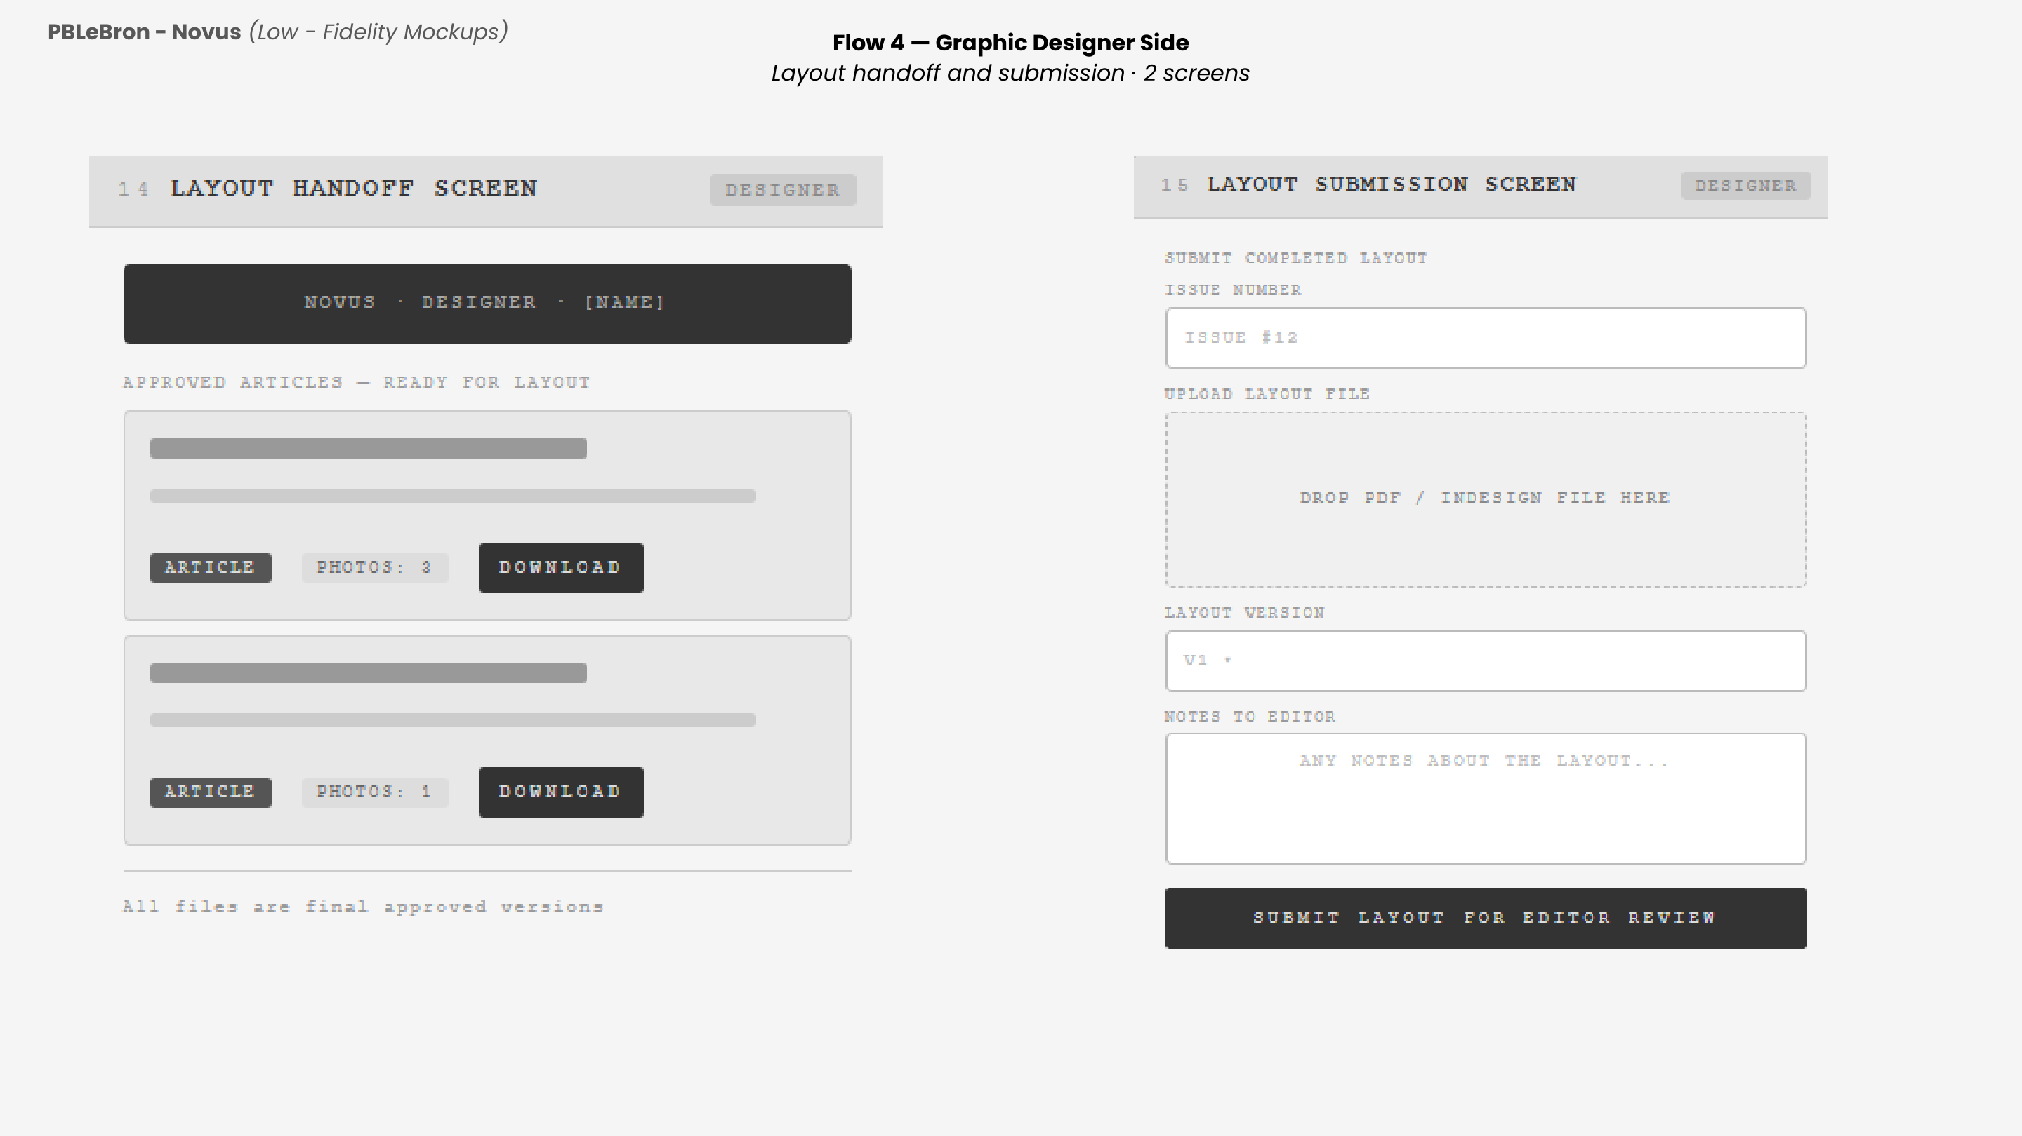
Fig. 4. Flow 4 — Graphic Designer Side. Layout Handoff (14) and Layout Submission (15).

Figure 5 shows the publisher's oversight and sign-off screens. The Pipeline View (16) surfaces issue readiness, layout status, publishing date, and days remaining at a glance. The Publishing Confirmation (17) presents a magazine cover preview, a pre-publication checklist, and publishing destination selectors (Website, Social Media) before the publisher triggers final release.

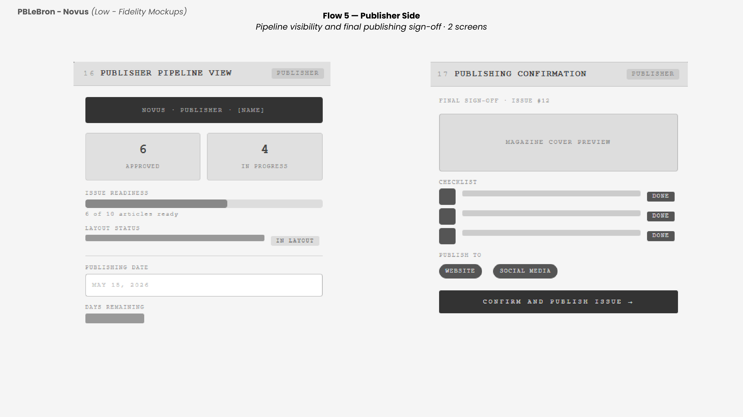
Fig. 5. Flow 5 — Publisher Side. Publisher Pipeline View (16) and Publishing Confirmation (17).

Figure 6 presents the reader-facing platform. The Homepage (18) features a hero article, category navigation, and a latest articles grid. The Article Listing Page (19) filters content by category. The Single Article View (20) renders full article content with a subscription prompt for gated access. The Subscription Page (21) offers monthly and annual tiers, with checkout handled through PayMongo (22) supporting GCash, Maya, credit, and debit card payments.
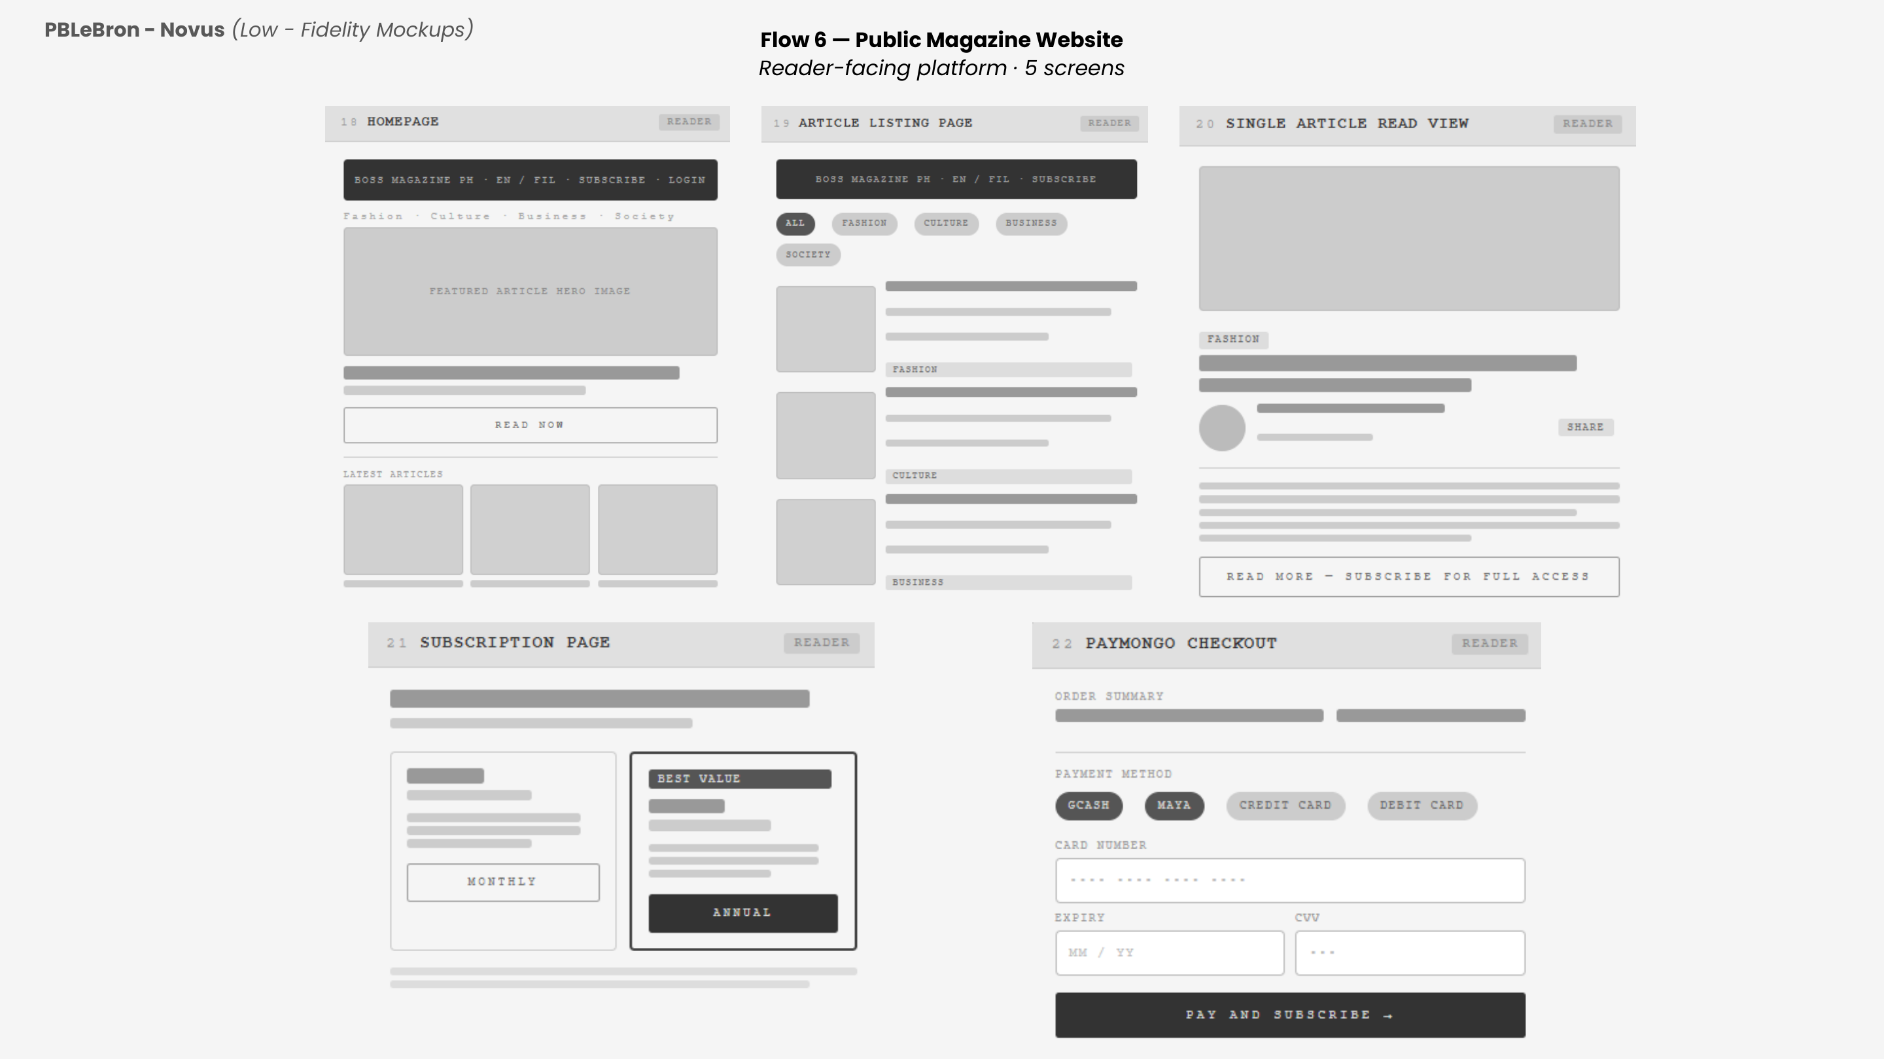
Fig. 6. Flow 6 — Public Magazine Website. Homepage (18), Article Listing (19), Single Article View (20), Subscription Page (21), and PayMongo Checkout (22).

Project Lean Canvas
The Lean Canvas (Fig. 7) summarizes the key strategic elements of Novus, including the identified problem, proposed solution, unique value proposition, unfair advantage, customer segments, key metrics, channels, cost structure, and revenue streams
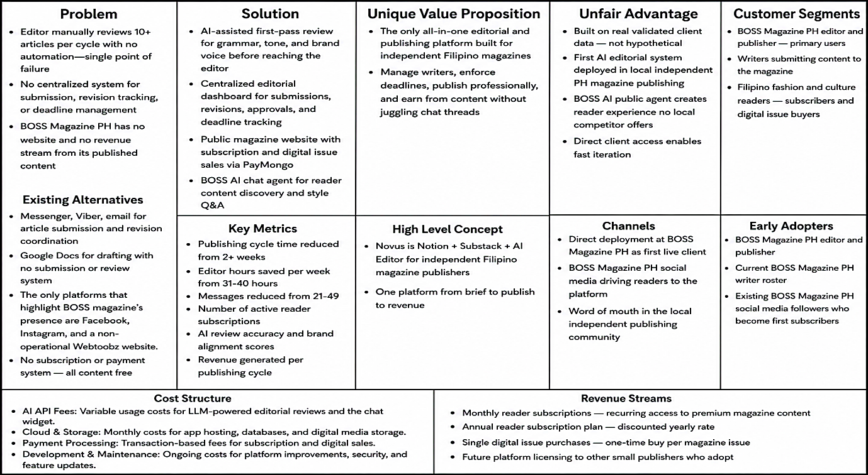
Fig. 7. Lean Canvas

User Classes and Characteristics
Table 5 describes the six user roles supported by the Novus platform, each with distinct permissions and responsibilities within the editorial and publishing lifecycle.
TABLE V.
User Classes
Roles | Description
Publisher | The publisher oversees the entire editorial and publishing operations of BOSS Magazine PH. This user has the highest level of access within the internal system, responsible for setting issue deadlines, publishing approved content to the public website, and monitoring subscription revenue and web analytics.
Editor | The editor manages the editorial workflow end-to-end. This user creates and assigns article briefs to writers, reviews submitted drafts, requests revisions or approves final articles, and forwards approved content to the client for sign-off before publication.
Writer | The writer is a content creator assigned to produce articles for the magazine. This user receives assignment briefs through the platform, drafts and submits articles for editorial review, and responds to revision notes until the article is approved.
Graphics Designer | The graphics designer is responsible for the visual production of the magazine. This user receives approved articles and their materials, uploads layout previews and asset versions, and submits the final PDF bundle for editorial and client review.
Reader | A reader is a member of the public who accesses the BOSS Magazine PH public portal. This user can browse articles by category, toggle between English and Filipino content, interact with the AI chat assistant, and opt into the email newsletter. Readers have access to free-tier content only.
Subscriber | A subscriber is a reader who has completed registration and payment to access premium content. This user inherits all capabilities of a standard reader and additionally gains access to paywalled articles, full digital issues, bookmarking, and subscription management through their profile.
Product Backlog
The product backlog in Table 6 captures all user stories across the six user roles, each with a story title, user story, and acceptance criteria. These items represent the functional requirements of Novus for the MNTSDEV phase and will be implemented incrementally across the three academic terms.
TABLE VI.
Product Backlog
Persona | Story Title | User Story | Acceptance Criteria
Writer | Centralized Drafting Workspace | As a writer, I want a single workspace to draft and submit my articles, so that I don't have to juggle different applications. | 1. Dashboard includes a rich-text editor with basic formatting.  2. A 'Submit for Review' button changes status from 'Drafting' to 'In Review'.  3. Writers can see the status of all their submitted articles from the dashboard.  4. Editor notes and revision history are accessible within the same workspace.
Writer | Cloud Auto-Save | As a writer, I want my drafts to automatically save in the cloud as I type, so that I never lose my progress. | 1. System saves documents automatically every 30 seconds or upon pausing.  2. A visual indicator ('Saved to Cloud') appears when successful.  3. Writers can view a save history and restore a previous version within the last 7 days.  4. Auto-save works even during network interruptions, syncing once connectivity is restored.
Writer | Contextual Revision Notes | As a writer, I want the editor's revision notes attached directly to my work, so that feedback is clear and contextual. | 1. Editor comments appear highlighted inline or in a side panel.  2. Writers can mark a comment as 'Resolved' once the edit is made.  3. Resolved comments are archived and remain viewable in a collapsed state.  4. Writer receives an in-app notification when new revision notes are added by the editor.
Writer | Pinned Assignment Briefs | As a writer, I want my assignment briefs pinned to my writing screen, so that I always know the exact requirements. | 1. Toggleable side-panel displays Topic, Word Count, Tone, and Deadline directly next to the editor.  2. A brief panel remains visible even while scrolling through the document.  3. Writer cannot edit the brief; it is read-only to preserve editor instructions.
Writer | Deadline Tracking and Reminders | As a writer, I want a visual tracker and automated reminders for my due dates, so that I don't miss the deadline. | 1. Dashboard displays color-coded due date (Yellow <48hrs, Red <24hrs).  2. System automatically sends an email reminder 24 hours before the deadline.  3. Writer receives an additional in-app notification 1 hour before the deadline.  4. Overdue articles are flagged with a distinct 'Overdue' badge and moved to the top of the dashboard.
Editor | AI Pre-Screening Engine | As an editor, I want an AI assistant to scan incoming drafts for grammar first, so that I don't waste hours reading flawed submissions. | 1. System automatically runs text through grammar APIs upon submission.  2. Generates Pass/Fail score.  3. Automatically reject drafts exceeding threshold.  4. Editor receives a detailed AI report showing flagged sentences and their matched sources.  5. Editor can override an AI rejection and manually approve a draft with a written justification.
Editor | Scrum Sprint Board | As an editor, I want a visual board tracking the current publishing cycle, so that I can see the status of every article at a glance. | 1. Board features columns: To-Do, Drafting, Under Review, Needs Revision, Approved.  2. Editor can drag and drop cards to manually override status.  3. Each card displays the article title, assigned writer name, and deadline.  4. Editor can filter the board by writer, deadline, or priority flag.
Editor | 1-Click Approvals and Rejections | As an editor, I want a single button to request revisions or lock a final draft, so that the approval process is immediate and secure. | 1. 'Approve' locks manuscript from writer edits and flags as ready.  2. 'Request Revision' changes status, unlocks writer access, and triggers notification.  3. Editor must enter a brief reason before confirming 'Request Revision' to ensure actionable feedback.  4. An audit log records all approval and rejection actions with timestamp and editor name.
Editor | Agile Reassignment and Priority | As an editor, I want the ability to easily reassign an active article or flag it as urgent, so that the publishing cycle isn't delayed. | 1. Editor can change assigned writer via dropdown.  2. The 'Priority' toggle adds a highly visible red flag to the article card on the Scrum board.  3. A newly assigned writer receives an immediate email and in-app notification with brief details.  4. Reassignment history is logged and visible to admin for accountability.
Graphics Designer | Asset Submission Dashboard | As a graphical designer, I want a dedicated submission space to upload my image previews and final PDF bundles, so that my work is linked to the correct article. | 1. UI accepts image (JPG/PNG) and document (PDF) uploads.  2. Uploaded files automatically link to the corresponding Article ID.  3. Designer receives a confirmation message with a thumbnail preview after a successful upload.  4. Editor is notified when new assets are submitted for their assigned article.
Graphics Designer | Version Control | As a graphical designer, I want to upload multiple versions of an image without overwriting old ones, so that the editor can compare revisions. | 1. Uploading a new file creates a V2/V3 stack rather than deleting the original.  2. Both designer and editor can view file history.  3. Editor can leave a comment on a specific version to guide further revisions.  4. Designer can mark one version as 'Final' to indicate it is ready for publishing.
Graphics Designer | Brand Kit Access | As a graphical designer, I want access to a centralized 'Brand Kit' folder within the dashboard, so that my designs remain strict on brand. | 1. Read-only folder accessible containing official logos, hex codes, and typography files.  2. Files are organized by category (Logos, Colors, Fonts) for quick retrieval.  3. Admin can update Brand Kit files; designers are notified of any changes via in-app alert.
Publisher | Publishing and Deadlines | As a publisher, I want to enforce an issue deadline and push approved content directly to the live website, so that I don't have to manually post to social media. | 1. Publisher can set the global 'Issue Release Date' that syncs to all dashboards.  2. The 'Publish Issue' button makes all 'Approved' articles live on public portal.  3. System prevents publishing if any article in the issue is not in 'Approved' status.  4. Publisher receives a success confirmation with a count of articles published and a preview link.
Publisher | Financial and Subscription Dashboard | As a publisher, I want a revenue dashboard showing active subscriptions and earnings, so that I can track platform monetization. | 1. The dashboard displays MRR, total active subscribers, and recent transactions.  2. Data updates dynamically based on PayMongo webhooks.  3. Publisher can filter revenue data by date range (weekly, monthly, yearly).  4. Dashboard includes a chart showing subscriber growth trend over the past 12 months.
Publisher | Traffic Analytics | As a publisher, I want a web analytics dashboard tracking visitor traffic, so that I have concrete numbers for advertisers. | 1. The dashboard displays total page views, unique visitors, and top-performing articles for the current month.  2. Publisher can export analytics data as a CSV or PDF report.  3. Dashboard shows traffic source breakdowns (direct, search, social media).  4. Data refreshes automatically every 24 hours.
Admin | Role-Based Access Control (RBAC) | As an admin, I want to manage user accounts and assign them strict roles, so that I can guarantee users only access to their authorized tools. | 1. Admin can Create, Read, Update, Suspend accounts.  2. 'Writers' cannot access Editor or Publisher backend routes.  3. Role changes take effect immediately without requiring the affected user to log out and back in.  4. Admin receives an audit log entry for every account creation, role change, or suspension action.
Admin | API Token Monitoring | As an admin, I want a dashboard tracking our third-party API usage, so that I can prevent the platform from exceeding its technical budget. | 1. Dashboard visualizes total API calls for LLM services.  2. System generates alert when usage hits 90% of monthly limit.  3. Admin can view a breakdown of API usage per service.  4. Dashboard displays estimated cost-to-date based on current usage.
Admin | Global Settings and Maintenance | As an admin, I want a global settings panel to toggle features, so that I can put the public site in maintenance mode without altering code. | 1. Maintenance Mode toggle displays 'Coming Soon' to the public.  2. Internal users (Editors/Writers) can still access backend.  3. Admin can set a scheduled start and end time for maintenance mode to activate automatically.  4. A banner is shown to internal users warning them that the site is in maintenance mode.
Reader | Content Discovery and Responsive Reading | As a reader, I want a mobile-responsive website with clear categories, so that I can easily read articles on my phone. | 1. UI scales correctly on mobile without horizontal scrolling.  2. Articles sortable by category tags.  3. Readers can use a search bar to find articles by keyword or title.  4. Website achieves a minimum score of 90 on Google Lighthouse mobile performance audit.
Reader | Multilingual Toggle | As a reader, I want a simple toggle to switch the website between English and Tagalog, so that I can read in my preferred language. | 1. Toggle instantly translates static navigation and retrieves the corresponding language version of the article.  2. If a Tagalog version of an article does not exist, a notice is displayed and the English version is shown as fallback.  3. The reader's language preference is saved in their browser session, so it persists across page visits.
Reader | Registration and Checkout | As a reader, I want to securely check out using my local e-wallet or card, so that I can unlock premium content. | 1. Paywalled article prompts subscription CTA.  2. Secure routing through PayMongo.  3. Successful payment upgrades user to 'Subscriber'.  4. Reader receives a payment confirmation email with receipt and subscription details.  5. Failed payment displays a clear error message and prompts the reader to retry or use a different method.
Subscriber | Paywall Bypass | As a subscriber, I want to log in and instantly unlock premium articles, so that I get the value of my paid subscription. | 1. Authenticating with subscriber credentials removes paywall blur/truncation from all premium articles.  2. Premium access applies across all devices logged in with the same account.  3. If the subscription has expired, the user is shown a renewal prompt instead of full content.
Subscriber | Bookmark and Save | As a subscriber, I want to save specific articles to my profile, so that I can easily re-read them later. | 1. 'Save Icon' present in articles.  2. Saved articles populate in 'My Library' tab on profile page.  3. Subscribers can organize saved articles into custom folders or collections.  4. Subscribers can remove an article from 'My Library' at any time.
Subscriber | Subscription Management | As a subscriber, I want to manage or cancel my recurring billing from my settings, so that I maintain control over my finances. | 1. Profile displays the next billing date and tier.  2. 'Cancel Subscription' button prevents next charge and revokes premium access at end of cycle.  3. Subscriber receives a cancellation confirmation email with the date their access will end.  4. Subscriber is offered a pause or downgrade option before completing cancellation.
Product Roadmap
The product roadmap of Novus is aligned with the three-phase academic delivery schedule. Phase 1 (MNTSDEV) covers system design, requirements analysis, and high-fidelity prototype development. Phase 2 (MSYSADD) focuses on technical modeling, UML documentation, RAG pipeline design, and polyglot database schema definition. Phase 3 (MCSPROJ) delivers the final coded and tested system, including full API integrations, UAT, and production deployment.
Release Plan
The release plan follows the phased academic schedule: the initial design release is delivered at the end of MNTSDEV, the architectural and modeling release at the end of MSYSADD, and the fully functional production release at the end of MCSPROJ. Each release is subject to faculty review and client validation at BOSS Media Philippines.
Use Case Diagram
Fig. 8 presents the high-level use case diagram for Novus, illustrating the interactions between the six user roles and the two primary system modules: the Editorial Workflow and the Public Portal. System authentication is a mandatory precondition for all actors and has been omitted from the diagram to preserve readability.
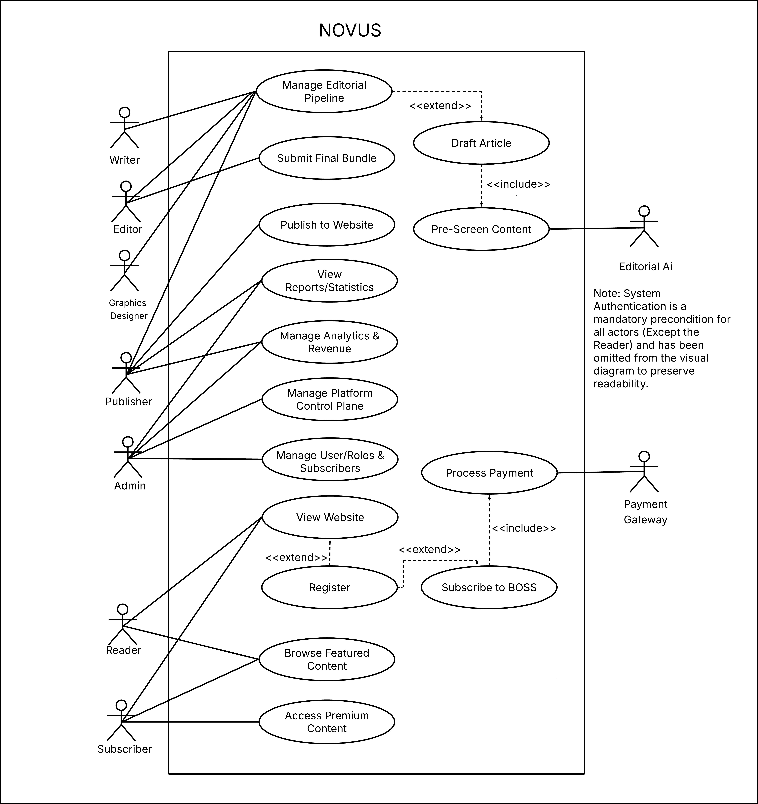

Fig. 8. Use Case Diagram High Level

Use Case Full Description
Table 6 provides a summary of all use cases within Novus, identifying each use case by ID, name, actor(s), description, and any include or extend relationships.
TABLE VII.
Use Case Summary
Use Case ID | Use Case Name | Actors | Description | Includes | Extends
UC-01 | Manage Editorial Pipeline | Writer, Editor, Graphics Designer | Allows editorial staff to manage article workflows, revisions, approvals, and content preparation before publication. | — | Draft Article
UC-02 | Draft Article | Writer | Allows writers to create and edit article drafts before submission. | Pre-Screen Content | Extends Manage Editorial Pipeline
UC-03 | Pre-Screen Content | Editorial AI | Uses AI to evaluate drafted articles for grammar, quality, and compliance before approval. | — | —
UC-04 | Submit Final Bundle | Editor | Allows editors to submit finalized article packages including text, graphics, and metadata for publishing. | — | —
UC-05 | Publish to Website | Publisher | Allows publishers to release approved content to the live website platform. | — | —
UC-06 | View Reports/Statistics | Publisher, Admin | Allows authorized users to monitor readership statistics, engagement, and platform reports. | — | —
UC-07 | Manage Analytics & Revenue | Publisher | Allows publishers to track monetization, subscriptions, and advertising performance. | — | —
UC-08 | Manage Platform Control Plane | Admin | Allows administrators to configure and maintain platform-wide operational settings. | — | —
UC-09 | Manage Users/Roles & Subscribers | Admin | Allows administrators to manage user accounts, permissions, and subscriber information. | — | —
UC-10 | View Website | Reader, Subscriber | Allows visitors and subscribers to access and navigate website content. | — | Extended by Register
UC-11 | Register | Reader | Allows readers to create an account in the system for personalized access and subscriptions. | — | Extends View Website, Subscribe to BOSS, Chat with AI Agent
UC-12 | Browse Featured Content | Reader, Subscriber | Allows users to explore highlighted or trending articles and media content. | — | Extends Chat with AI Agent
UC-13 | Subscribe to BOSS | Reader | Allows users to subscribe to premium services or membership plans. | Process Payment | Extends Register
UC-14 | Process Payment | Payment Gateway | Handles secure payment transactions for subscriptions and premium access. | — | Included in Subscribe to BOSS
UC-15 | Access Premium Content | Subscriber | Allows subscribed users to access exclusive articles and premium features. | — | Extends Chat with AI Agent

V. CONCLUSION
Accomplishments and Objective Fulfillment
During the MNTSDEV phase, the project layout, strategic framework, and systemic architecture for Novus: Smart Editorial & Publishing Platform were successfully established. The blueprint directly fulfills or architecturally positions the project's specific milestones for future execution:
- Workflow & Capacity (Design Achieved): Replaced the client's fragmented messaging-app routine (4+ apps, 21–49 daily messages) with a unified, stage-based visual Kanban pipeline framework mapping 100% of state changes.
- Workload Reduction (Architecturally Achieved): Modeled an asynchronous pre-screening queue using Gemini to provide grammar, tone, and a mathematical 100-point Brand Alignment Score within 60 seconds and providing a structured evaluation on the strong and weak points of the article.
- Portal Performance (Prototypes Developed): Finalized responsive web interfaces using Next.js and Tailwind CSS engineered to meet Google Lighthouse performance and accessibility targets.
- Monetization & Transactions (Architecture Established): Structured a hybrid payment engine integrating PayMongo (local e-wallets like GCash/Maya) and Stripe (global credit cards) to enable a sustainable reader subscription model.
Summary of Completed Work
Adhering to the EDIPT design thinking process and structured systems analysis, the team achieved the following project deliverables:
- Client Validation: Conducted a formal writer survey and interviews in March and April 2026, confirming an operational reliability rating of 1/5 for the current chat-dependent methods.
- Strategic Business Modeling: Authored a robust SWOT Analysis and Project Lean Canvas to guarantee commercial viability.
- Requirements Engineering: Produced an exhaustive Product Backlog compiling precise User Stories and detailed Acceptance Criteria across all 6 target roles.
- System Modeling: Developed High-Level Use Case Diagrams and Full Descriptions to rigorously map system boundaries.
- Infrastructure Blueprinting: Engineered a polyglot persistence database model—using PostgreSQL for transactional data, MongoDB for append-heavy audit trails, and Firestore for real-time synchronization —all deployed inside a private network on the Railway App Platform.
Next Iteration Framework (For MSYSADD)
To bridge the gap between architectural requirements and core system implementation , the next iteration during the MSYSADD (System Modeling and UML Documentation) subject will concentrate heavily on technical diagrams and database orchestration:
- Granular Structural Modeling: Translate current user stories and use cases into formal, deeply nested UML Class Diagrams, Sequence Diagrams, and State Machine Diagrams.
- Database Layer Rule Deployment: Implement declarative, server-side Firestore Security Rules tied tightly to Firebase Authentication to ensure role isolation and secure active article state sync.
- Asynchronous Integration Flow: Document backend sequencing queues to prevent third-party API rate-limiting (HTTP 429) during Gemini inference calls.
- Chronometry Tracking Prep: Model the precise database timestamp pipelines within the MongoDB infrastructure to calculate automated "Time-in-Status" statistics for upcoming User Acceptance Testing (UAT).

REFERENCES
[1] N. Newman, R. Fletcher, K. Eddy, C. T. Robertson, and R. K. Nielsen, "Reuters Institute Digital News Report 2023," Reuters Institute for the Study of Journalism, Oxford, U.K., 2023. [Online]. Available: https://reutersinstitute.politics.ox.ac.uk/sites/default/files/2023-06/Digital_News_Report_2023.pdf

[2] CFlow, "The State of Workflow Automation in Content Organizations," CFlow Documentation, 2024. [Online]. Available: https://www.cflowapps.com

[3] A. Partida, "Comparative review of newsroom CMS platforms," Int. J. Multidiscip. Res., vol. 6, no. 1, 2024.

[4] A. Adamou, E. González-Blanco, and G. del Rio Riande, "PubLink: Editorial workflow for digital scholarly publications in the humanities," in Proc. 2024 ACM Conf. Doc. Eng. (DocEng '24), 2024.

[5] E. Brechner, Agile Project Management with Kanban. Redmond, WA, USA: Microsoft Press, 2015.

[6] H. F. Cervone, "Understanding agile project management methods using Kanban," OCLC Systems & Services, vol. 27, no. 2, pp. 78-82, 2011.

[7] N. Y. Arifin et al., "Implementing fast content management to accelerate editorial workflows in a digital newsroom," Sinkron: J. Penelit. Tek. Inform., vol. 10, no. 1, pp. 792-800, Jan. 2026.

[8] A. Srivastava and S. Singh, "Accelerating editorial processes in scientific journals: Leveraging AI for rapid manuscript review," J. Appl. Res. Technol. Manag., vol. 3, no. 2, 2024.

[9] P. J. Hurley, W. J. Mayew, and A. P. Stephan, "When research speeds up but journals do not: AI's impact on accounting publishing," SSRN Scholarly Paper 5727142, 2025.

[10] Y. K. Dwivedi et al., "So what if ChatGPT wrote it? Multidisciplinary perspectives on opportunities, challenges and implications of generative conversational AI for research, practice and policy," International Journal of Information Management, vol. 71, p. 102642, 2023.

[11] N. Newman, R. Fletcher, K. Eddy, C. T. Robertson, and R. K. Nielsen, "Reuters Institute Digital News Report 2023," Reuters Institute for the Study of Journalism, Oxford, U.K., 2023.

[12] Deployteq, "Challenges facing the publishing and media industry in 2024," Mar. 11, 2024.

[13] T. Oliveira, M. Thomas, G. Baptista, and F. Campos, "Mobile payment: Understanding the determinants of customer adoption and intention to recommend the technology," Computers in Human Behavior, vol. 61, pp. 404-414, 2016.

[14] R. Radu, "Revisiting subscription-based business models: Recurring billing systems and customer retention in SaaS platforms," Journal of Business and Technology, vol. 9, no. 2, pp. 45-61, 2021.

[15] J. Hamari, N. Hanner, and J. Koivisto, "What drives subscribing to premium in freemium services? A consumer value-based view of differences between upgrading to and staying with premium," Inf. Syst. J., vol. 30, no. 2, pp. 327-349, Mar. 2020.

[16] P. Jamshidi, C. Pahl, N. C. Mendonça, J. Lewis, and S. Tilkov, "Microservices: The journey so far and challenges ahead," IEEE Software, vol. 35, no. 3, pp. 24-35, May/Jun. 2018.

[17] M. Fowler and P. J. Sadalage, NoSQL Distilled: A Brief Guide to the Emerging World of Polyglot Persistence. Boston, MA, USA: Addison-Wesley, 2012.

[18] J. Gray and A. Reuter, Transaction Processing: Concepts and Techniques. San Mateo, CA, USA: Morgan Kaufmann, 1992.

[19] B. G. Tudorica and C. Bucur, "A comparison between several NoSQL databases," in Proc. IEEE ROEDUNET, 2011.

[20] A. Davoudian, L. Chen, and M. Liu, "A survey on NoSQL stores," ACM Computing Surveys, vol. 51, no. 2, pp. 1-43, 2018.

[21] D. Caivano et al., "Real-time notifications in collaborative workflow systems," Journal of Systems and Software, 2021.

[22] N. Mehta and N. Rozanski, "Notification architecture patterns for multi-audience platforms," IEEE Software, 2022.

[23] J. H. Saltzer and M. D. Schroeder, "The protection of information in computer systems," Proceedings of the IEEE, vol. 63, no. 9, 1975.

[24] D. Basin, M. Clavel, and M. Egea, "A decade of model-driven security," in Proc. 15th ACM Symposium on Access Control Models and Technologies, pp. 1-10, 2010.

[25] E. Pitler and A. Nenkova, "Revisiting readability: A unified framework for predicting text quality," in Proc. 2008 Conference on Empirical Methods in Natural Language Processing (EMNLP), pp. 186-195, 2008.

[26] E. Dale and J. S. Chall, "A formula for predicting readability," Educational Research Bulletin, vol. 27, no. 1, pp. 11-28, 1948.

[27] M. Koppel, J. Schler, and S. Argamon, "Computational methods in authorship attribution," Journal of the American Society for Information Science and Technology, vol. 60, no. 1, pp. 9-26, 2009.

[28] I. Grigorik, High Performance Browser Networking. Sebastopol, CA, USA: O'Reilly Media, 2013.

[29] P. Bhatt et al., "Transactional email deliverability in cloud-native applications," International Journal of Computer Applications, 2023.

[30] Resend, "React Email: Building transactional email with component-based templates," Resend Developer Documentation, 2024.

[31] J. H. Saltzer and M. D. Schroeder, "The protection of information in computer systems," Proceedings of the IEEE, vol. 63, no. 9, 1975.

[32] H. Kniberg and M. Skarin, Kanban and Scrum: Making the Most of Both. C4Media, 2010.

[33] E. Brechner, Agile Project Management with Kanban. Redmond, WA, USA: Microsoft Press, 2015.

[34] D. Spinellis, "Version control systems," IEEE Software, vol. 22, no. 5, pp. 108–109, 2005.

[35] N. B. Ruparelia, "The history of version control," ACM SIGSOFT Software Engineering Notes, vol. 35, no. 1, pp. 5–9, 2010.

[36] H. F. Cervone, "Understanding agile project management methods using Kanban," OCLC Systems & Services, vol. 27, no. 2, pp. 78–82, 2011.

[37] R. Flesch, "A new readability yardstick," Journal of Applied Psychology, vol. 32, no. 3, pp. 221–233, 1948.

[38] J. P. Kincaid, R. P. Fishburne, R. L. Rogers, and B. S. Chissom, "Derivation of new readability formulas for Navy enlisted personnel," Research Branch Report 8-75, Naval Technical Training Command, 1975.

[39] E. Pitler and A. Nenkova, "Revisiting readability: A unified framework for predicting text quality," in Proc. 2008 Conference on Empirical Methods in Natural Language Processing (EMNLP), pp. 186–195, 2008.

[40] E. Dale and J. S. Chall, "A formula for predicting readability," Educational Research Bulletin, vol. 27, no. 1, pp. 11–28, 1948.

[41] G. U. Yule, The Statistical Study of Literary Vocabulary. Cambridge University Press, 1944.

[42] F. J. Tweedie and R. H. Baayen, "How variable may a constant be? Measures of lexical richness in perspective," Computers and the Humanities, vol. 32, no. 5, pp. 323–352, 1998.
[43] M. Koppel, J. Schler, and S. Argamon, "Computational methods in authorship attribution," Journal of the American Society for Information Science and Technology, vol. 60, no. 1, pp. 9–26, 2009.

[44] M. A. Covington and J. D. McFall, "Cutting the Gordian knot: The Moving-Average Type-Token Ratio (MATTR)," Journal of Quantitative Linguistics, vol. 17, no. 2, pp. 94–100, 2010.

APPENDICES
Appendix A: Roles and Responsibilities
1. Rei Khalil S. Galido – Lead Systems Analyst & Database Architect
- Core Role: Responsible for high-level system architecture, requirements verification, data modeling strategies, and alignment of client objectives with technical specifications.
- Key Responsibilities:
  - Led the engineering of the polyglot persistence database model (PostgreSQL, MongoDB, and Cloud Firestore integration rules).
  - Authored the high-level and granular Use Case Diagrams and Use Case Full Descriptions to establish explicit system boundaries.
  - Designed the backend asynchronous integration workflow blueprint for the Gemini AI modules.
  - Managed the mapping of the legacy "As-Is" manual workflow to the proposed "To-Be" Kanban automated pipeline.
2. Roman Rico B. Albania – Business Analyst & Scrum Master
- Core Role: Focused on business feasibility, project lifecycle management, timeline tracking, and structuring functional system requirements.
- Key Responsibilities:
  - Conducted strategic business modeling, including the development of the Project Lean Canvas and the comprehensive SWOT Analysis.
  - Formulated and maintained the Product Backlog, ensuring all User Stories and strict Acceptance Criteria met client expectations.
  - Conducted operational and economic feasibility studies to calculate resource allocations and performance targets.
  - Coordinated sprint activities, documented meeting outcomes, and maintained the project roadmap timelines.
3. Joshmar L. Clavero – Front-End Engineer & UI/UX Designer
- Core Role: Responsible for transforming functional requirements into tangible visual interfaces, establishing design systems, and conducting user research.
- Key Responsibilities:
  - Designed and constructed the high-fidelity, interactive front-end web wireframes and dashboards using Next.js, React, and Tailwind CSS.
  - Deployed responsive, mobile-first layouts tailored for the distinct user environments of the 6 core user classes.
  - Executed the quantitative writer surveys and client interviews to extract and validate real-world operational bottlenecks.
  - Ran initial compliance testing against Google Lighthouse frameworks to establish critical performance and accessibility baselines.

Appendix B: Minutes of the Meetings
Date: March 17, 2026
Time: 12:30 PM – 1:30 PM
Attendees: Felino Calderon III (Adviser), Roman Rico Albania, Rei Khalil Galido, Joshmar Clavero
Objective/Purpose: The meeting was convened to define the core system architecture and infrastructure for the dual editorial and e-commerce platforms.

Agenda Review: 1. System Integration & Database
- Defined the ERP (internal) and E-commerce (external) systems.
- Established that both systems will interconnect through a shared database.
- Infrastructure & Deployment
  - Identified GoDaddy for hosting and Heroku as the primary PaaS for the startup.
  - Established a requirement for development to match the production environment using sandbox servers.
- Operational Targets
  - Set a goal to reduce writer feedback turnaround from 2–3 days to within a single day.
  - Identified the need for multi-lingual support and Dragonpay integration.
Adjournment: The meeting adjourned at 1:30 PM.

Date: March 24, 2026
Time: 12:30 PM – 1:30 PM
Attendees: Felino Calderon (Adviser), Roman Rico Albania, Rei Khalil Galido, Joshmar Clavero
Objective/Purpose: The meeting focused on establishing a design thinking framework and refining user research methodologies.

Agenda Review: 1. User Role Identification
- Defined five key user roles: Admin, Writer, Editor, Publisher, and Reader.
- Methodology & Survey Flow
  - Adopted the EDIPT framework (Empathy, Define, Ideate, Prototype, Test).
  - Structured survey flow to move from connection-building and identification to ratings and remarks.
  - Introduced Root Cause Analysis (RCA) for identifying system bottlenecks.
- Process Mapping
  - Decided on Activity Diagrams for end-to-end process visualization.
  - Established that the new system process must clearly show where users engage with the application.
Adjournment: The meeting adjourned at 1:30 PM.

Date: March 31, 2026
Time: 12:30 PM – 1:30 PM
Attendees: Felino Calderon (Adviser), Roman Rico Albania, Rei Khalil Galido, Joshmar Clavero
Objective/Purpose: To outline the Software Development Life Cycle (SDLC) and establish strategic business modeling tools.

Agenda Review: 1. SDLC & Testing Phases
- Established a seven-stage cycle: Planning, Analyze, Design, Development, Testing, Monitoring, and Control.
- System Scope & Boundaries
  - Noted that diagrams should use broken lines to show connections outside the primary system.
  - Focused on using "As-Is" processes to actively shorten writer publishing steps.
- Strategic Documentation
  - Initiated SWOT Analysis and Lean Canvas development.
  - Defined the Business Case as a foundational document for stakeholder persuasion and funding.
Adjournment: The meeting adjourned at 1:30 PM.
Date: April 7, 2026
Time: 12:30 PM – 1:30 PM
Attendees: Felino Calderon (Adviser), Roman Rico Albania, Rei Khalil Galido, Joshmar Clavero
Objective/Purpose: To classify the application's financial model and initiate academic research components.

Agenda Review: 1. Application Classification
- Analyzed whether the system functions as an "Income Generating" or "Cost Savings" application.
- Identified subscriptions as a primary revenue stream for income generation.
- Performance Rubrics
  - Set a requirement for IEEE-formatted rubrics to evaluate the Lean Canvas professionally.
- Research & Ideation
  - Commenced work on Review of Related Literature (RRL) and Review of Related Studies (RRS).
  - Agreed to document all panelist feedback in a formal comment matrix.
Adjournment: The meeting adjourned at 1:30 PM.

Date: April 11, 2026
Time: 3:30 PM – 5:15 PM
Attendees: Client (Editor), Felino Calderon (Adviser), Roman Rico Albania, Rei Khalil Galido, Joshmar Clavero
Objective/Purpose: To gather direct client feedback on current pain points and validate the proposed "Novus" system.

Agenda Review: 1. Pain Point Assessment
- Client confirmed a reliability rating of 1/5 for the current system.
- Identified multiple communication channels (Viber, Messenger, WhatsApp, etc.) as the biggest miscommunication bottleneck.
- Current editorial workload was rated at 4/5.
- Proposed Features
  - Client approved the name "Novus" and requested a color-coded (Red, Green, Yellow) status tracking scheme.
- Project Constraints
  - Client validated the problem statement but raised concerns regarding AI text humanization.
Adjournment: The meeting adjourned at 5:15 PM.


Date: April 17, 2026
Time: 12:30 PM – 1:30 PM
Attendees: Felino Calderon (Adviser), Roman Rico Albania, Rei Khalil Galido, Joshmar Clavero
Objective/Purpose: To simplify project objectives and refine the technical integration of AI agents.

Agenda Review: 1. Objective Simplification
- Simplified fragmented objectives into a single, measurable paragraph.
- Focused on tracking all submissions (new, revised, rejected) in one channel.
- Specified a need for concrete article and content counts.
- AI & Infrastructure
  - Introduced notification management to prove reduction in message volume.
  - Evaluated Gemini AI and its combination with RAG for response generation.
  - Justified the selection of AWS and Vercel for infrastructure.
- Performance Metrics
  - Addressed API limits, output verification, and system scalability.
  - Outlined a plan to measure and prove that Novus AI reduces editorial workload.
Adjournment: The meeting adjourned at 1:30 PM.

Date: April 21, 2026
Time: 12:30 PM – 1:30 PM
Attendees: Felino Calderon (Adviser), Roman Rico Albania, Rei Khalil Galido, Joshmar Clavero
Objective/Purpose: The meeting was convened to map the granular "As-Is" manual procedures and establish efficiency benchmarks for the "To-Be" system.

Agenda Review: 1. Process Granularity & Triggers
- Identified the need to distinguish between controllable and uncontrollable processes.
- Defined the requirement to identify the specific individual or event that triggers the start of the article-writing cycle.
- Efficiency Benchmarking
  - Established a goal to optimize manual tasks so they can be completed within 20–30 minutes in the new system.
  - Directed the team to interview staff to measure the exact duration of current manual workflows.
- Activity Diagramming
  - Required specific activity diagrams for three primary roles: Writers, Editors, and Clients.
  - Documented a detailed 11-step manual procedure involving Editors, Graphics Designers, and Clients to serve as a baseline for system automation.
Adjournment: The meeting adjourned at 1:30 PM.
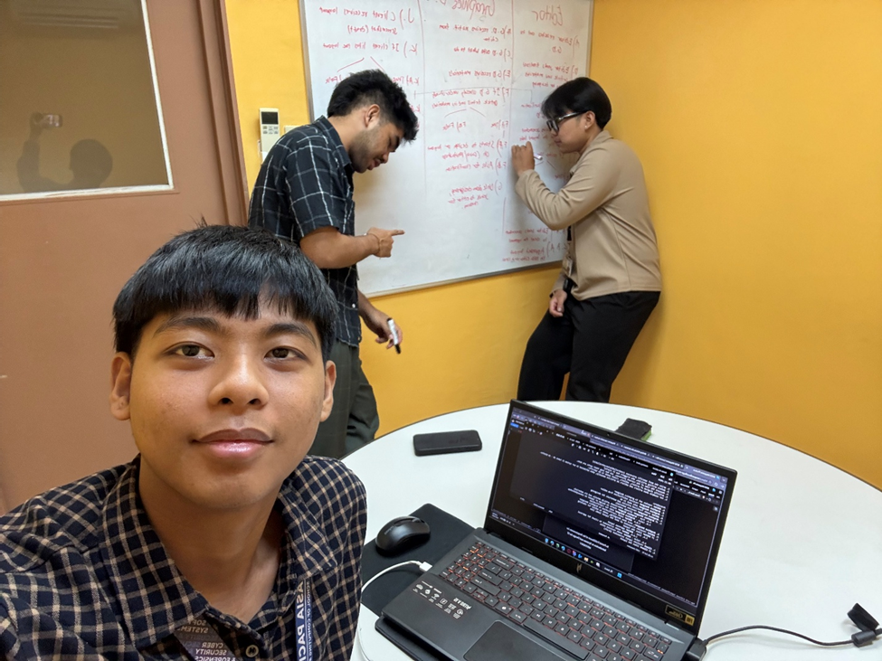

Date: April 28, 2026
Time: 12:30 PM – 1:30 PM
Attendees: Felino Calderon (Adviser), Roman Rico Albania, Rei Khalil Galido, Joshmar Clavero
Objective/Purpose: To develop comprehensive user stories and acceptance criteria for all project personas.

Agenda Review: 1. Requirements Standards
- Established that all user stories must have specific tasks and follow acceptance criteria.
- Persona Dashboards
  - Writer: Focused on centralized workspaces and revision notes attached directly to work.
  - Editor: Requirements included AI assistants for grammar scans and automated writer reminders.
  - Admin: Focused on RBAC, third-party API tracking, and subscription oversight.
  - Designer: Requested dashboards for article access and submission of PDF bundles with revision notes.
Adjournment: The meeting adjourned at 1:30 PM.
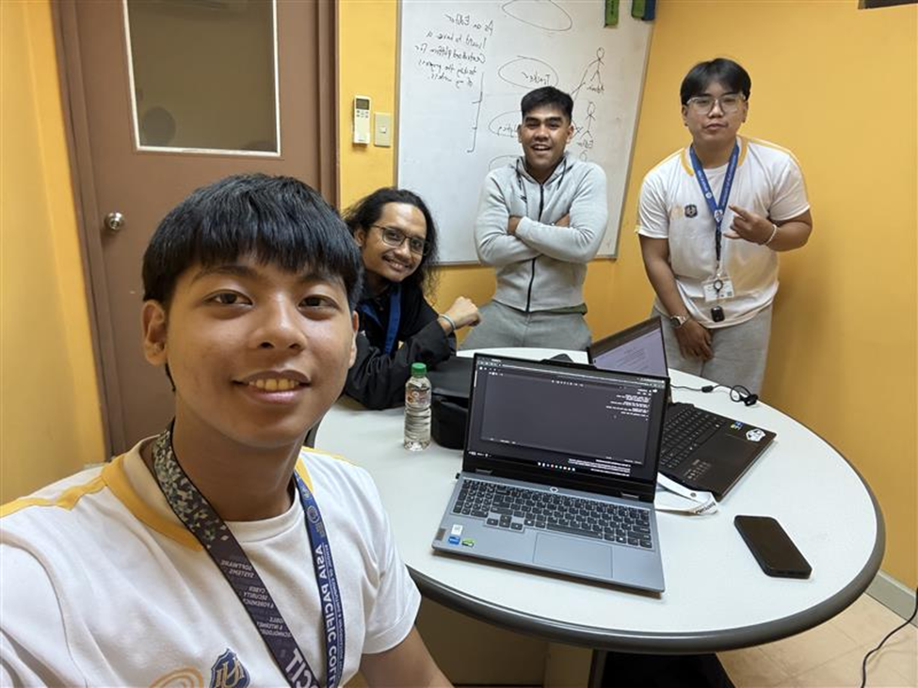

Date: May 12, 2026
Time: 11:30 AM – 12:30 PM
Attendees: Felino Calderon (Adviser), Roman Rico Albania, Rei Khalil Galido, Joshmar Clavero
Objective/Purpose: To define the functional requirements for the public-facing portal and the external subscriber management system.
Agenda Review: 1. Public Portal Requirements
- Defined features for external users, including registration and subscription capabilities.
- Mandated that the subscription workflow must "include" a formal payment step.
- Subscriber Experience
  - Confirmed that every subscriber must have a personalized user profile.
  - Initiated a study on automated notification triggers for new article releases.
- Technical Alignment
  - Directed the creation of a new Use Case diagram specifically for the subscription module.
  - Ensured all new technical diagrams remain strictly aligned with established User Stories.
Adjournment: The meeting adjourned at 12:30 PM.

Appendix C: Methodology
The development team followed the EDIPT (Empathy, Define, Ideate, Prototype, Test) Design Thinking framework to systematically engineer the Novus platform:
- Empathy: Conducted multi-round focus groups and an operational writer survey (March–April 2026) with the BOSS Magazine PH staff to trace operational pain points, uncovering a heavily fractured workflow relying on 4+ independent communication apps.
- Define: Synthesized raw findings into definitive problem boundaries—highlighting the Editor-in-Chief’s unsustainable 31–40 hour weekly review overhead and a critical 1/5 score in current system operational reliability.
- Ideate: Constructed a Comprehensive Product Backlog containing precise User Stories, strict role boundaries for 6 unique user classes, and cross-referenced acceptance criteria to design a streamlined, stage-based visual Kanban pipeline.

Date: May 19, 2026
Time: 12:30 PM – 1:30 PM
Attendees: Felino Calderon (Adviser), Roman Rico Albania, Rei Khalil Galido, Joshmar Clavero
Objective/Purpose: To evaluate alternative backend deployment hosting environments, map downstream data flows, and establish prototype validation testing methodologies.
Agenda Review: 1. Data Streams & Backend Infrastructure Alternatives * Reviewed the downstream flow of data and how the system passes information between connected architectures.
- Evaluated Vercel, Firebase, and Railway as alternative cloud deployment platforms for application and backend hosting.
- Security & Centralized Logging * Reconfirmed Role-Based Access Control (RBAC) as the correct solution for authorization security and user threat mitigation.
- Selected Splunk as the centralized logging system to trace user actions and monitor external threats.
- Prototyping Standards & UX Framework * Standardized three prototyping tiers across the paper: Low-Fidelity, Mid-Fidelity layouts, and High-Fidelity interactive screens with clickable transition animations.
- Adopted the "Think Aloud" system validation methodology, structuring focus group feedback by what worked, what failed, what was confusing, and what ideas are next.
- Governance & Task Matrix * Required high-level solutions to follow strict SMART formatting and include a bilingual website feature.
- Set up a four-column Comment Matrix tracking: Who, Comment, Action, and Assigned To.
Adjournment: The meeting adjourned at 1:30 PM.

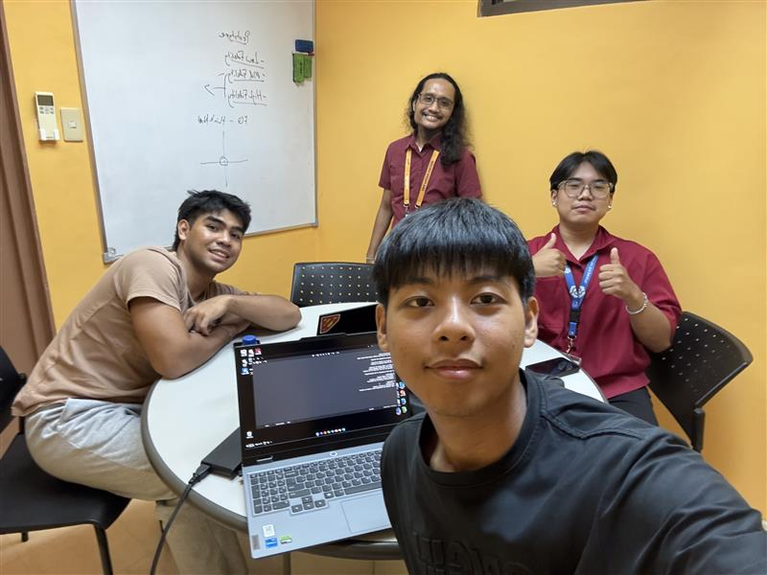

Appendix D: Project SharePoint Link
URL: https://asiapacificcollege.sharepoint.com/:u:/r/sites/PBLeBron/SitePages/Home.aspx?csf=1&web=1&share=IQDteGznmG0jS5gZ2YQ8Ey4vAeVqPoyUuCYg_XhNnL0bzhw&e=6iDjPs

Appendix E: Requirements Traceability Matrix
Business Problem ID | Functional Requirement / Feature | Product Backlog User Story ID | Associated Use Case ID | Verification Method (UAT / Target)
BP-01: Fractured coordination across 4+ chat apps | Stage-based automated Kanban workflow tracking | US-001 (Editorial Tracking) | UC-01: Manage Article Pipeline | Time-in-Status database metric logging
BP-02: 31-40 hr editor screening workload | Gemini Asynchronous AI Pre-screening Agent | US-002 (AI Assessment) | UC-02: Auto-Evaluate Draft | Execution complete in $<60$ seconds
BP-03: Vulnerability to third-party social algorithms | Public Reader Portal & Premium Paywalls | US-003 (Reader Subscription) | UC-03: Process Subscription | Successful Stripe/PayMongo checkout sequence
BP-04: Unstructured legacy magazine archives | Deep Semantic Search Engine via Gemini 1.5 Pro | US-004 (RAG Reader Assistant) | UC-04: Query Archive | Paragraph-level vector source citations

Appendix F: RACI Matrix
Engineering / Project Task Domain | Rei Khalil S. Galido | Roman Rico B. Albania | Joshmar L. Clavero | Joint / Collaborative Contribution
System Behavior & Functional Modeling | Lead  (Authored Unified Use Case Diagrams & full narrative system behavioral specifications) | Support  (Reviewed functional flows for backlog consistency) |  | All Members  (Collaboratively generated and integrated Review of Related Literature (RRL) data)
Requirements Engineering & Backlog Management |  | Lead  (Engineered the Product Backlog, defined User Stories, and compiled detailed Acceptance Criteria) |  | All Members  (Contributed to the writing, refinement, and proofreading of the core documentation components)
Strategic Business Analysis |  | Lead  (Formulated the Project Lean Canvas, Feasibility Studies, and SWOT analysis) |  | All Members  (Contributed to the writing, refinement, and proofreading of the core documentation components)
UI/UX Design & High-Fidelity Prototyping |  |  | Lead  (Architected interactive wireframes, front-end system dashboards, and mobile responsive flows) | All Members  (Contributed to the writing, refinement, and proofreading of the core documentation components)
Stakeholder Coordination & Advisory Liaison | Lead  (Primary point of contact for technical advisor consultations and academic milestone approvals) |  | Lead  (Primary communications liaison for industry client feedback loops and user interviews) | All Members  (Collaboratively aligned system capabilities with advisor and client requirements)
Project Management & Lifecycle Tracking |  | Lead  (Maintained sprint velocity charts, tracked item-by-item progress, and organized meeting minutes) |  | All Members  (Adhered to sprint timelines and completed assigned documentation modules)

Appendix G: Survey Results Writer
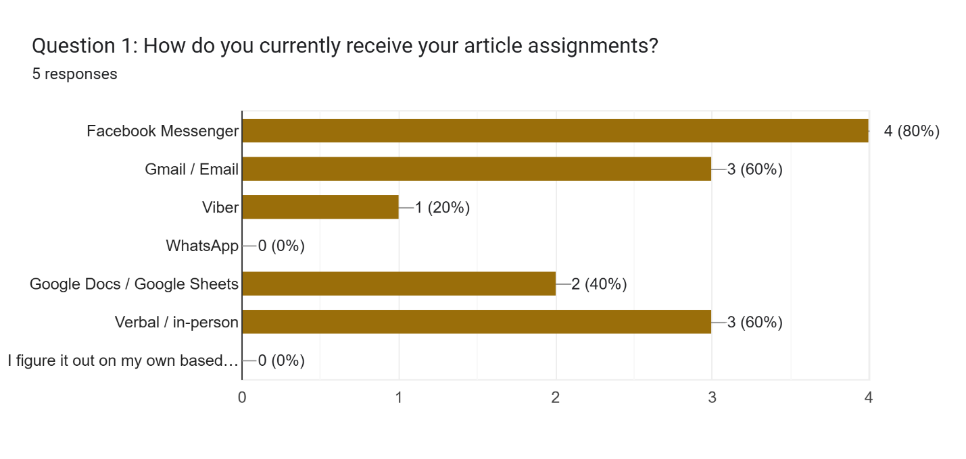
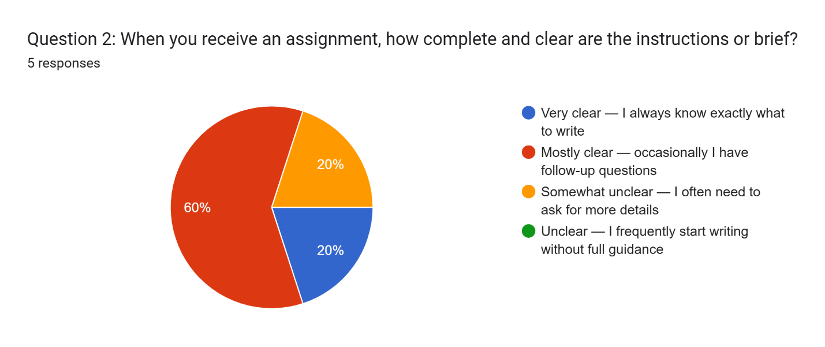
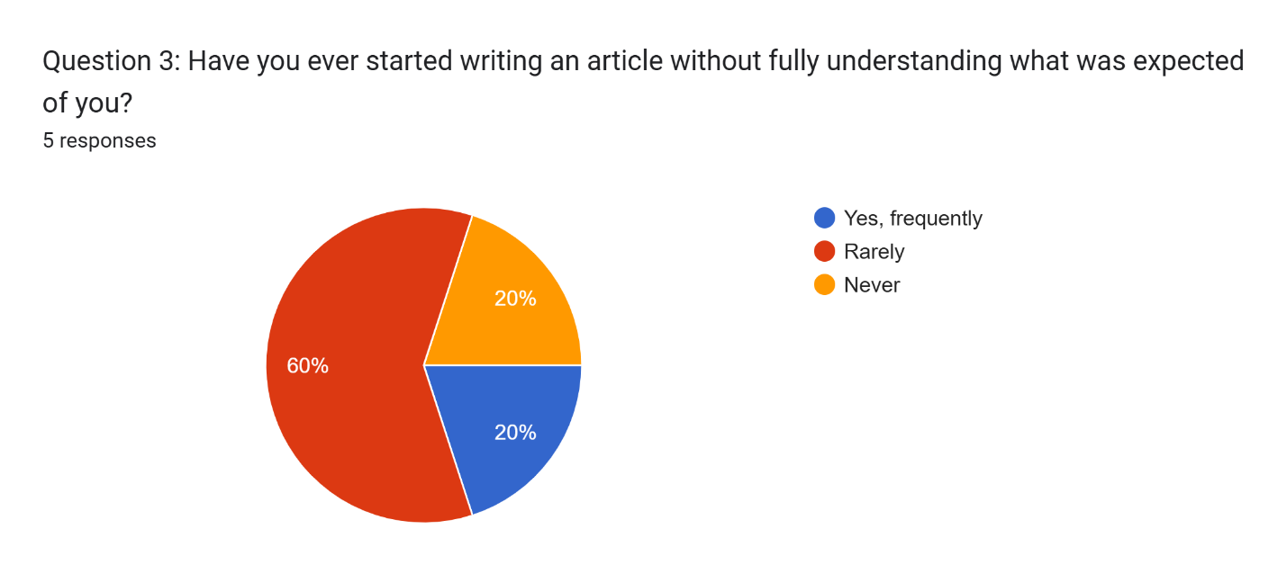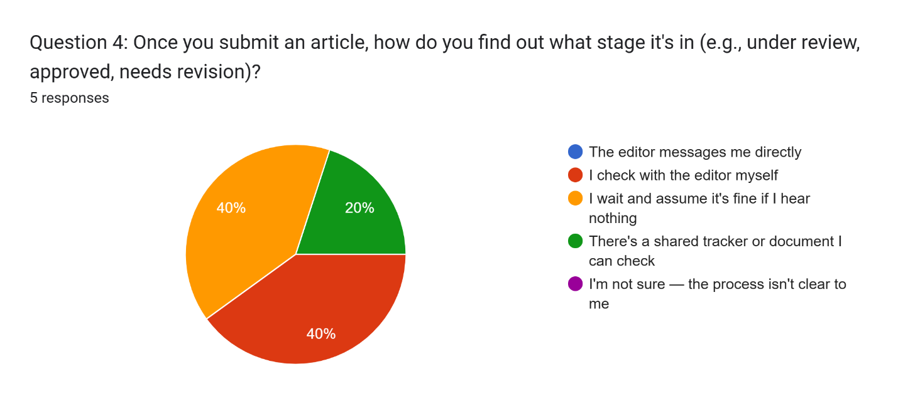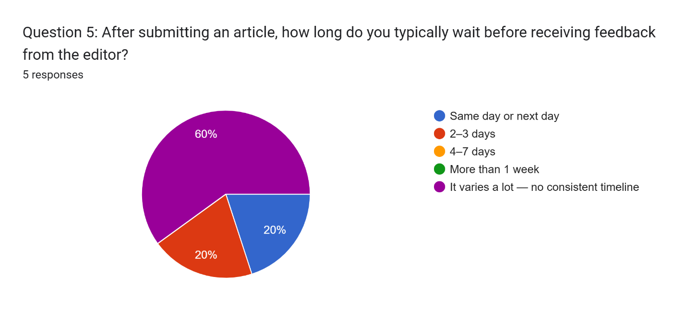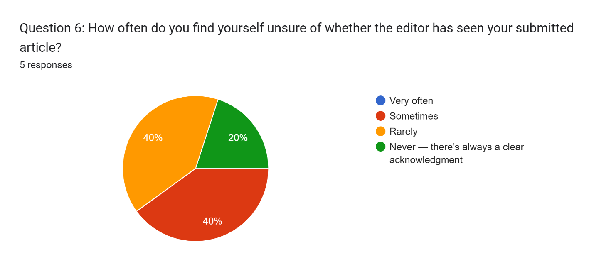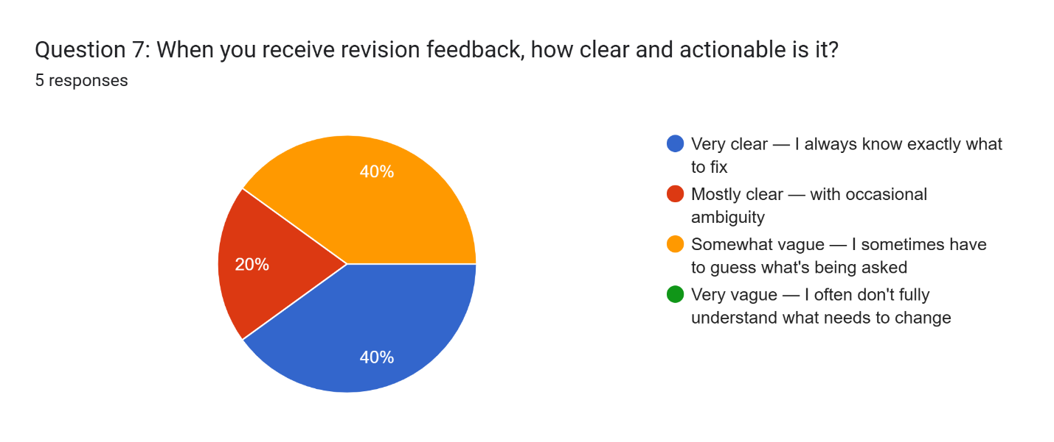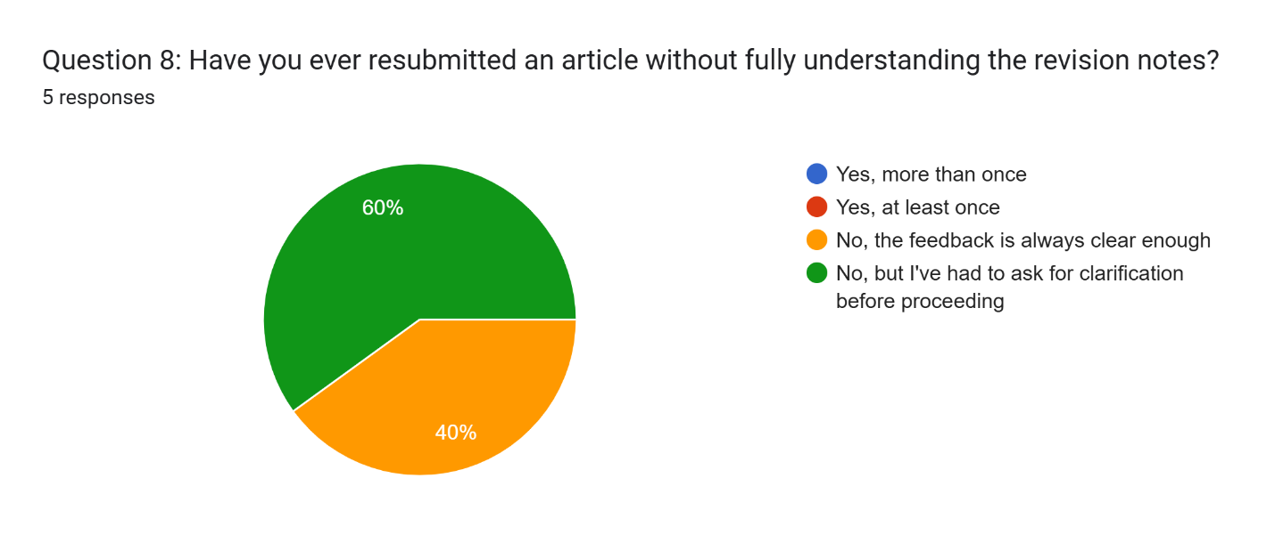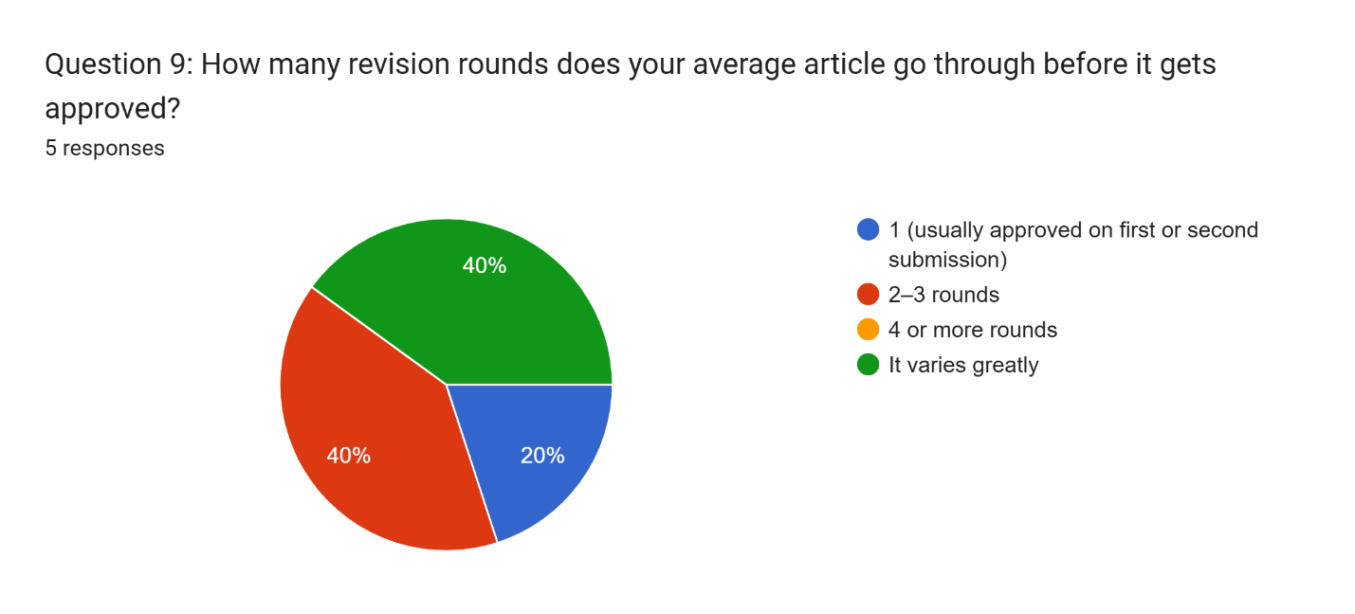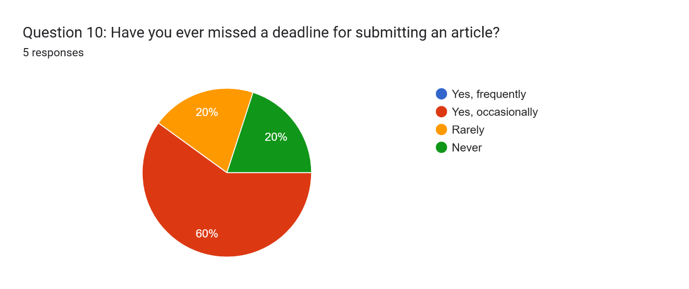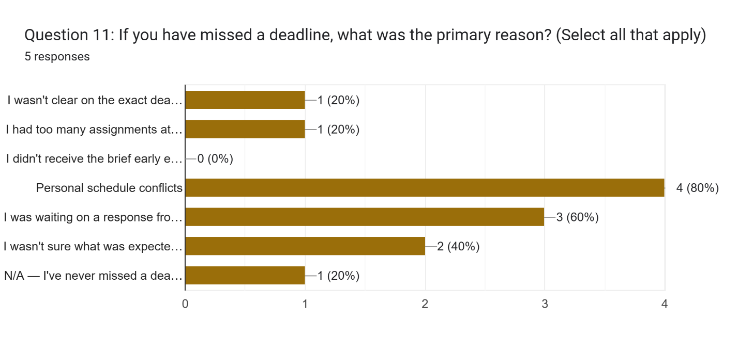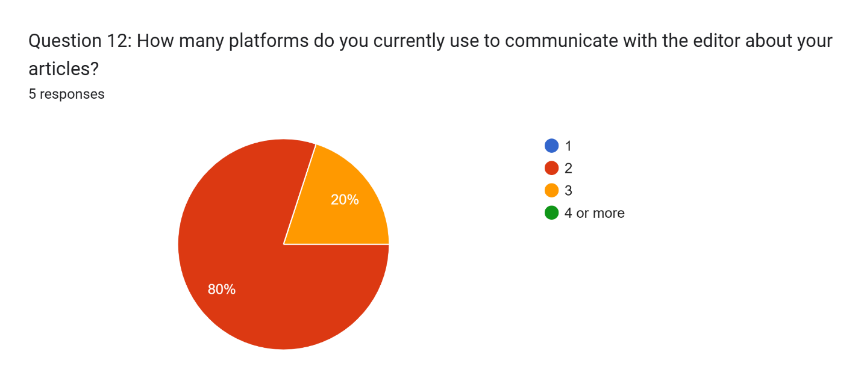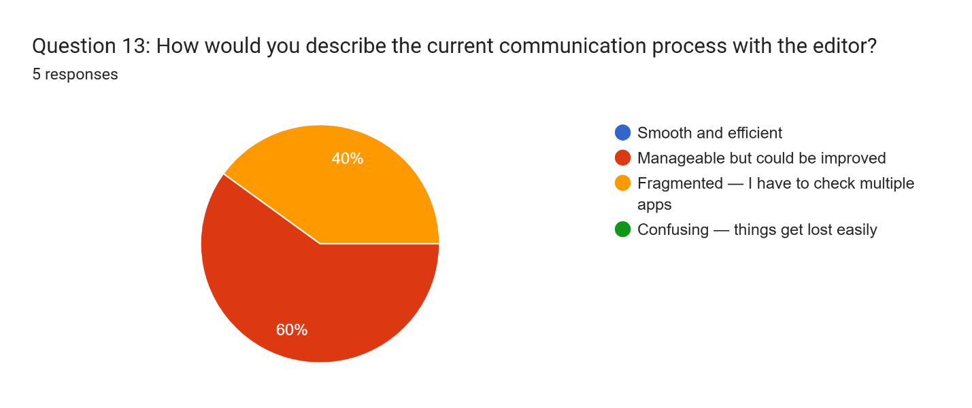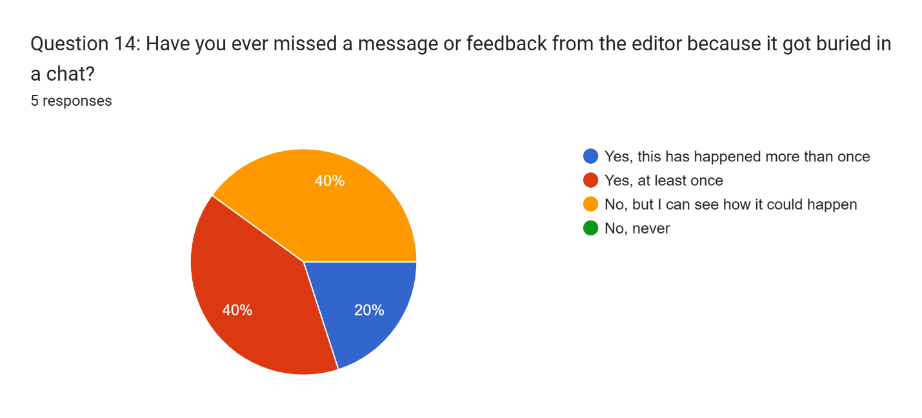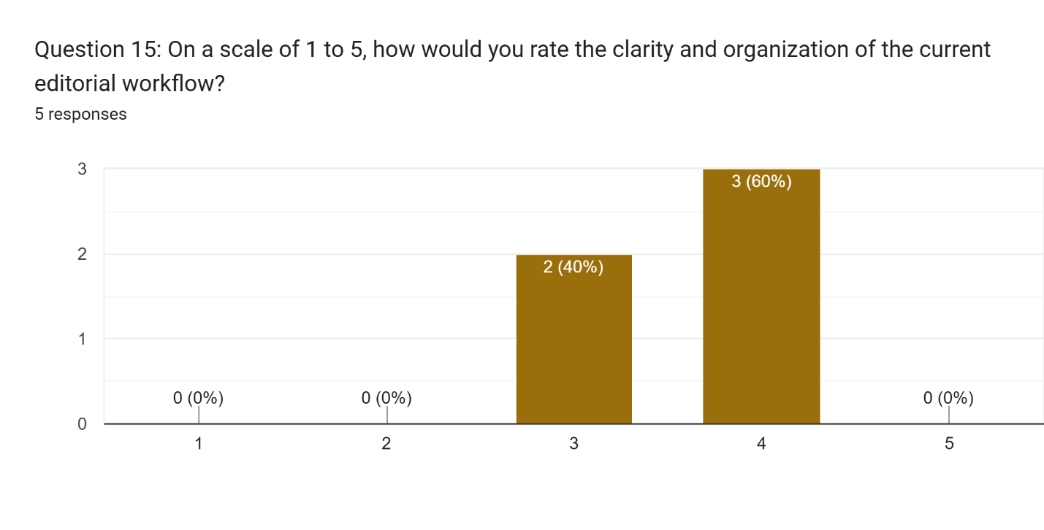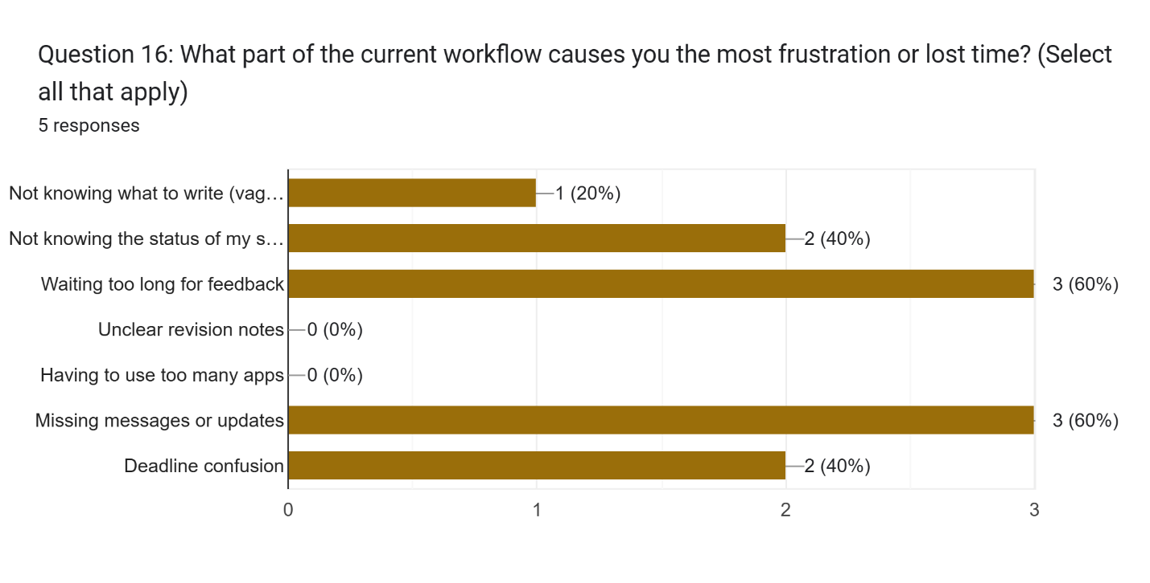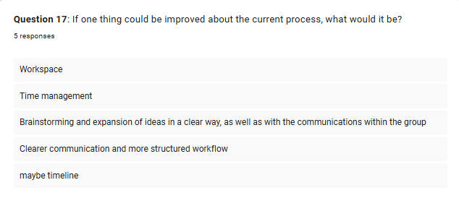

Appendix H: Survey Results Editor
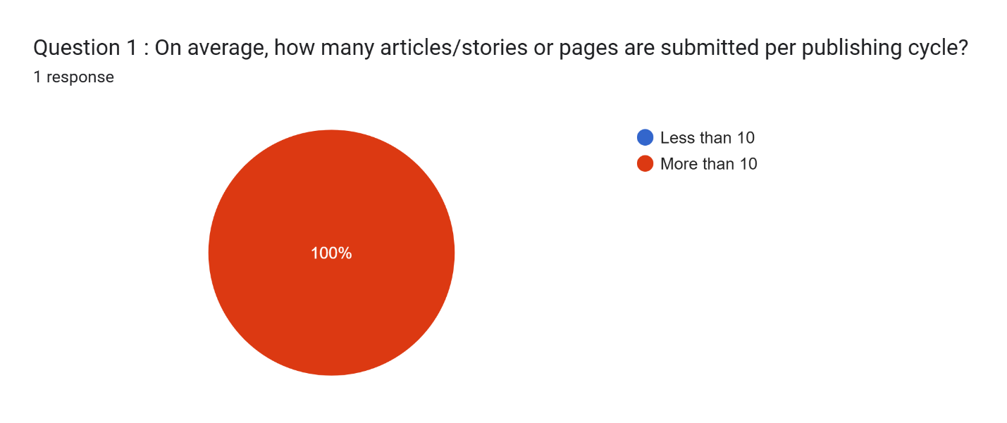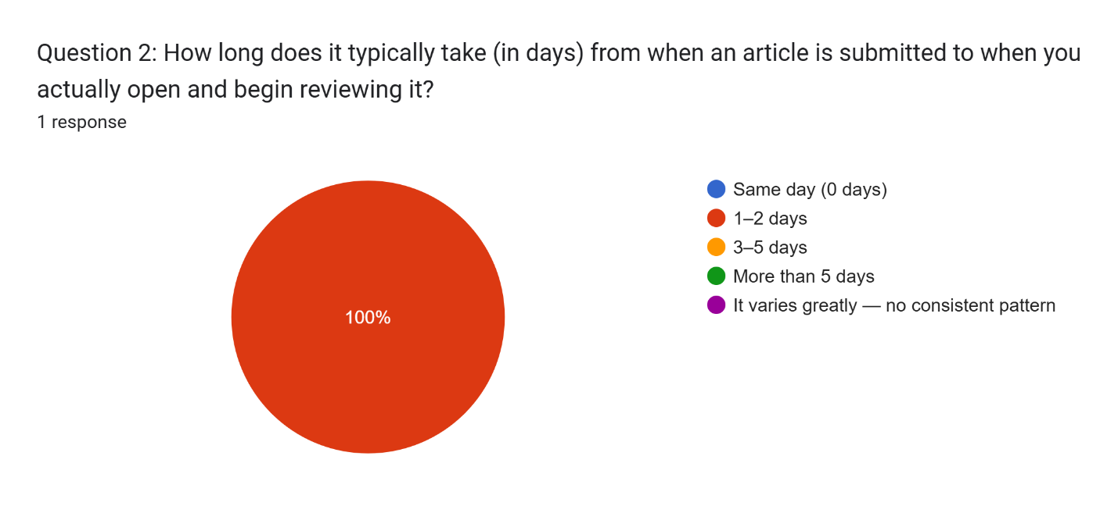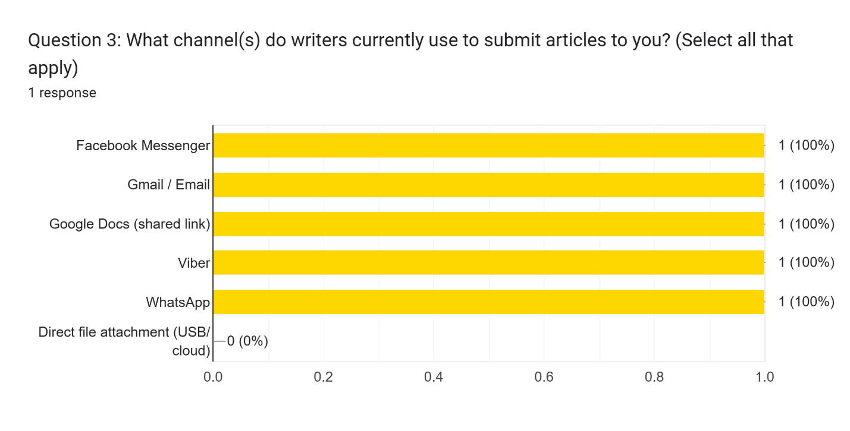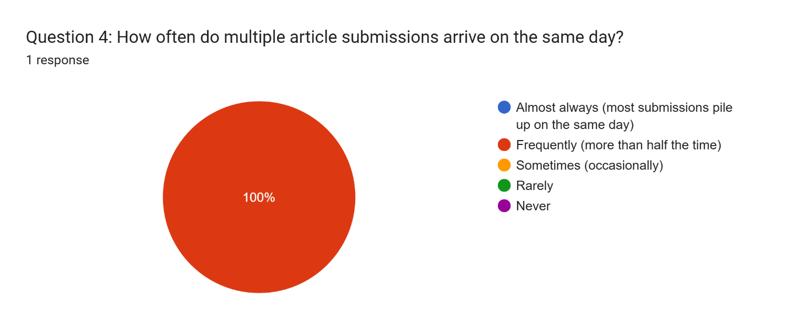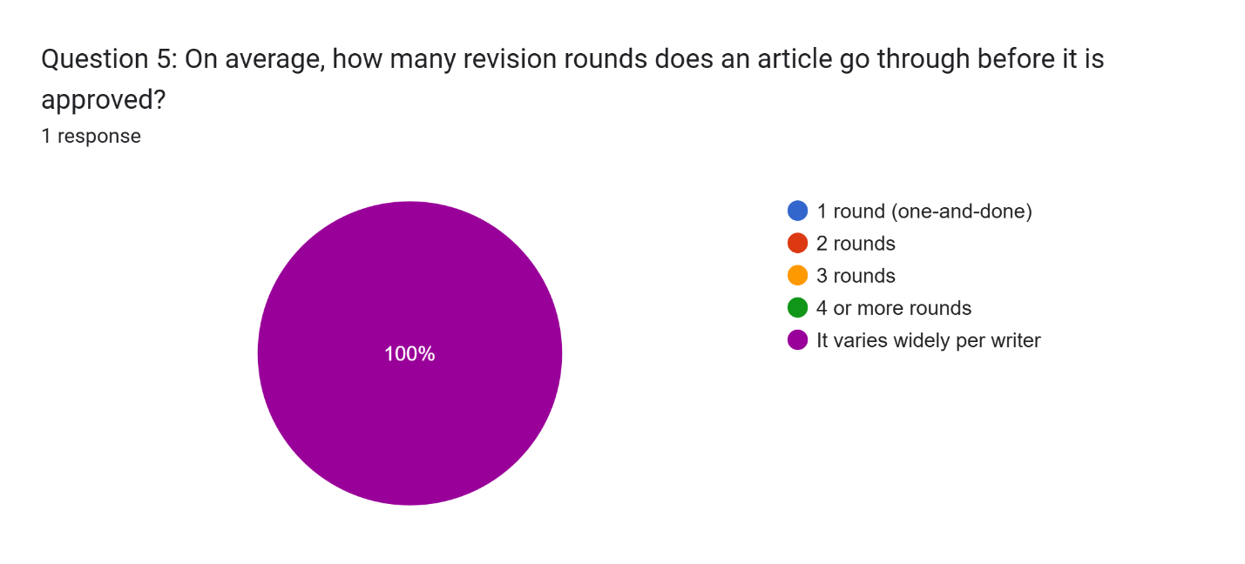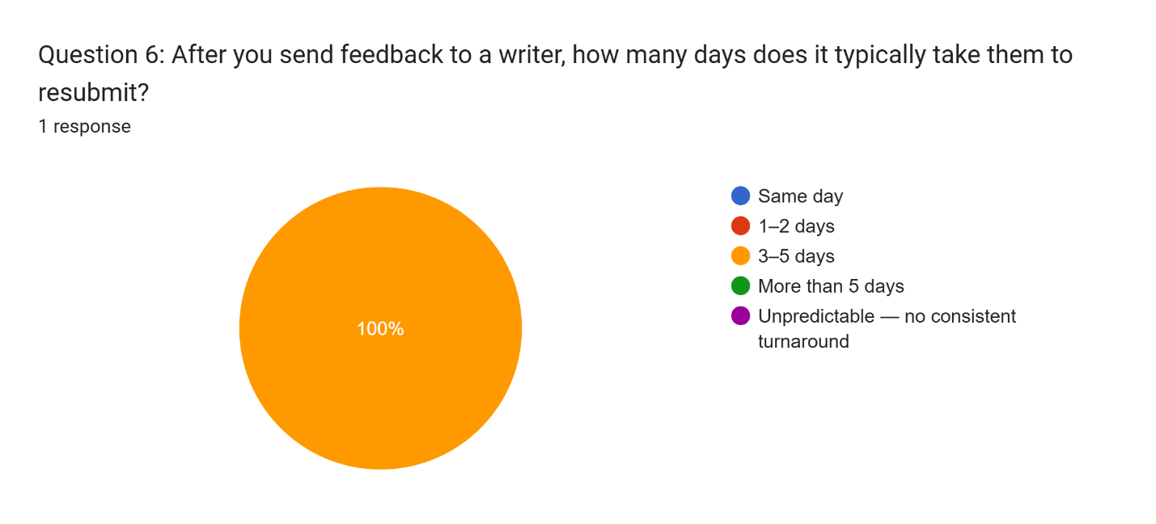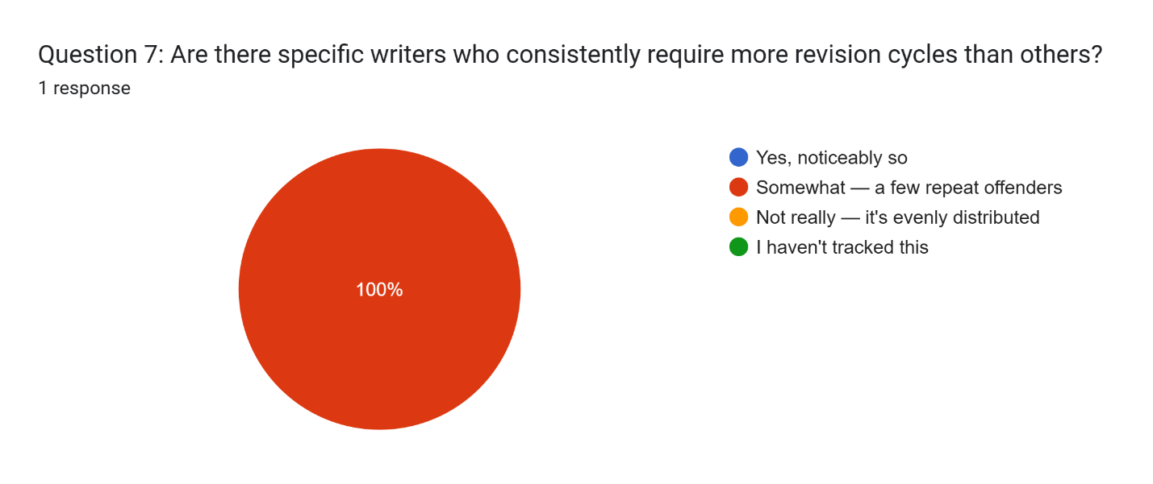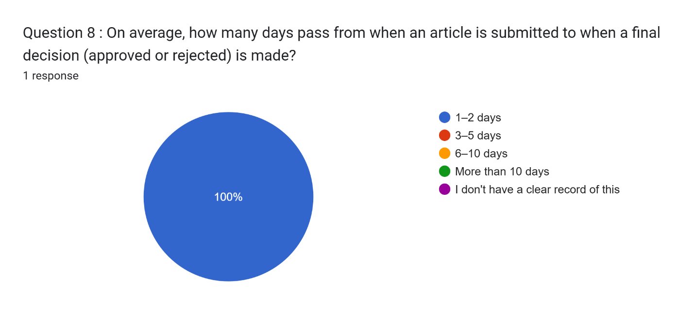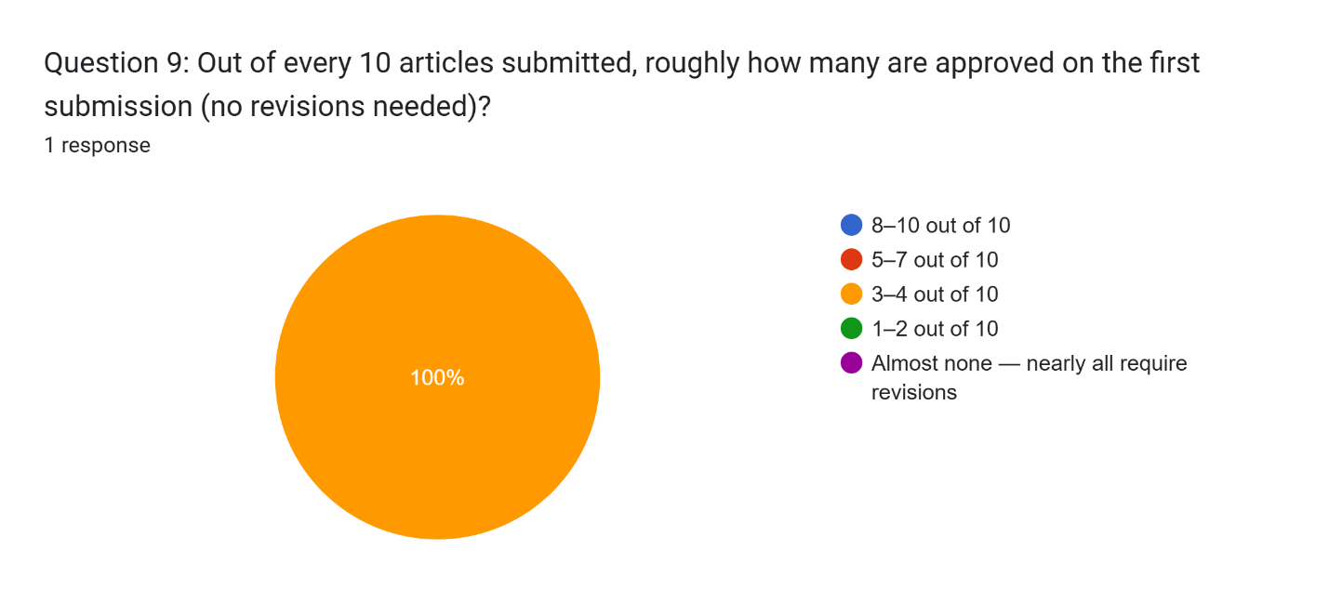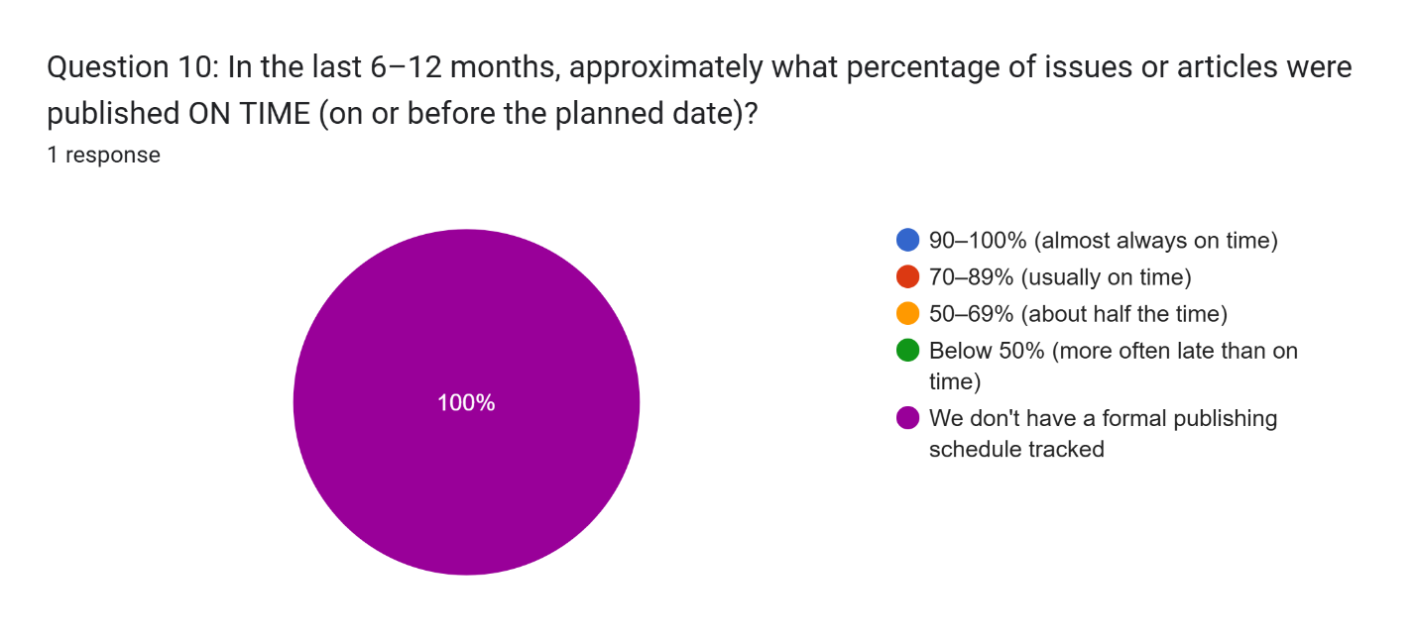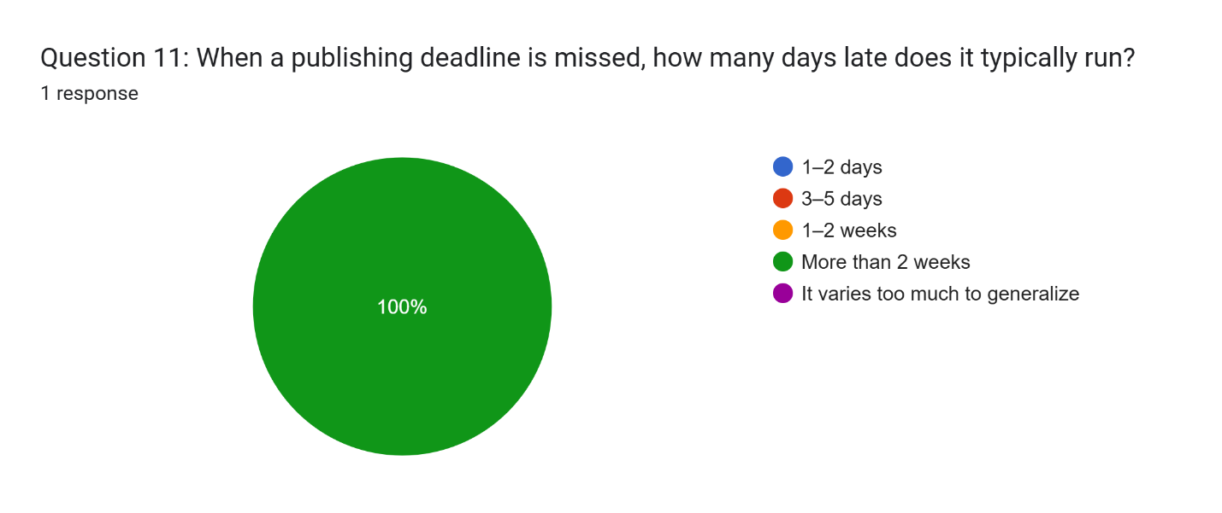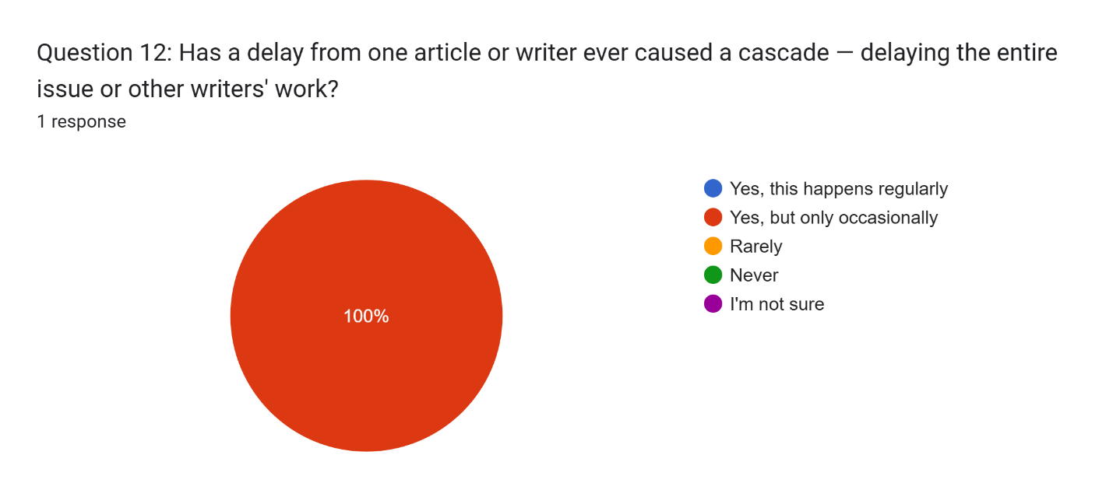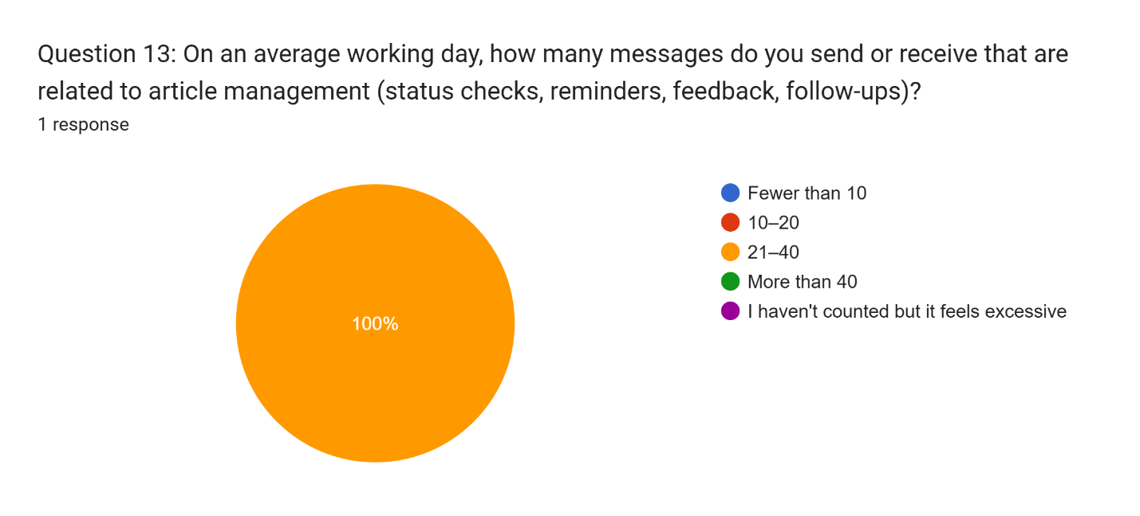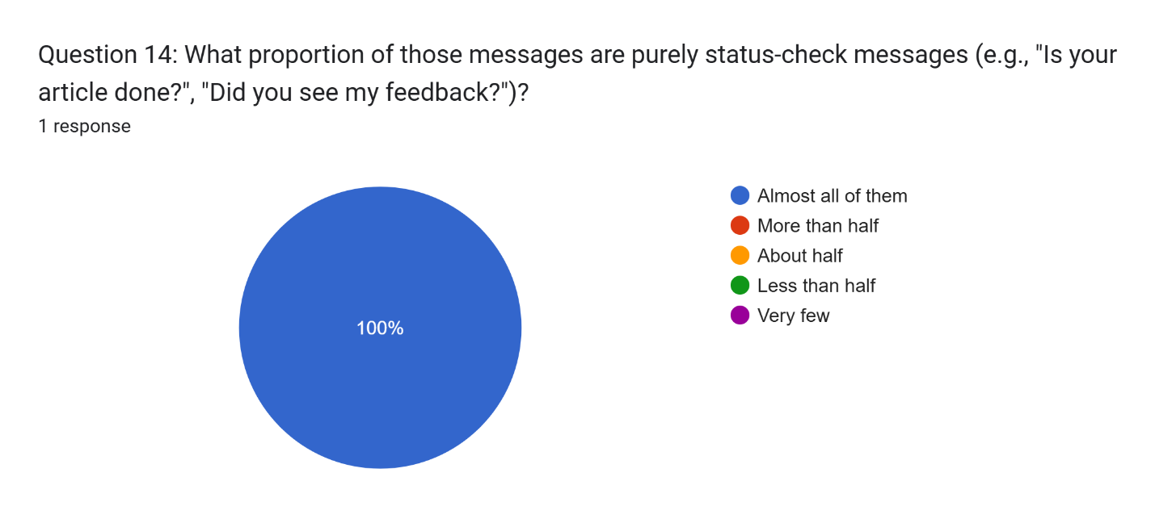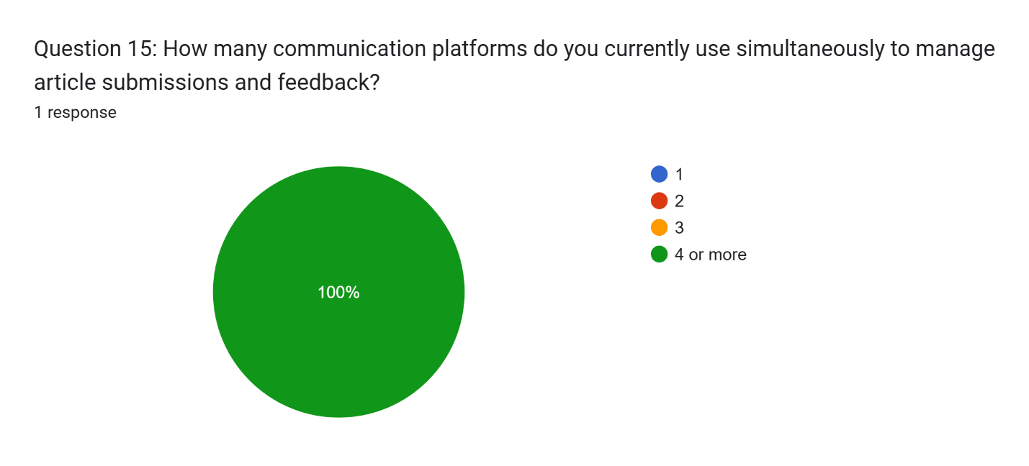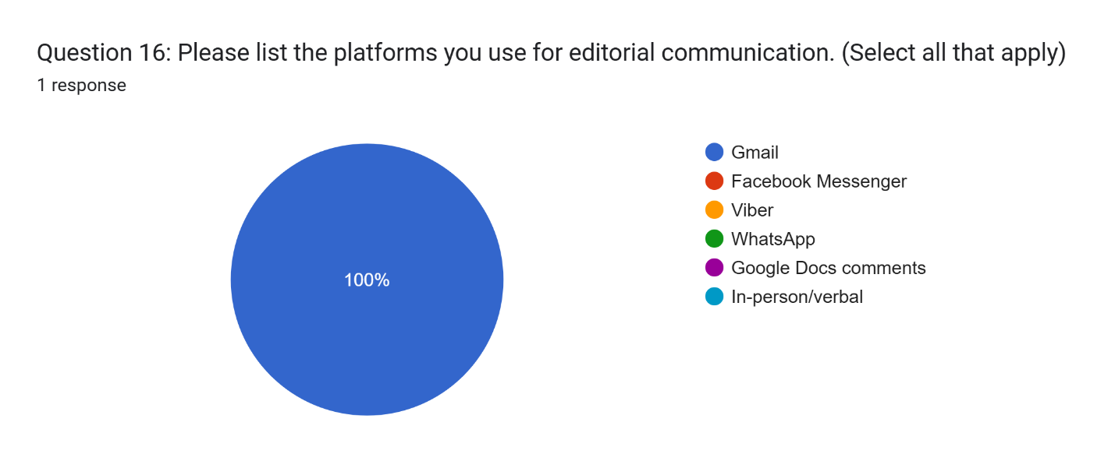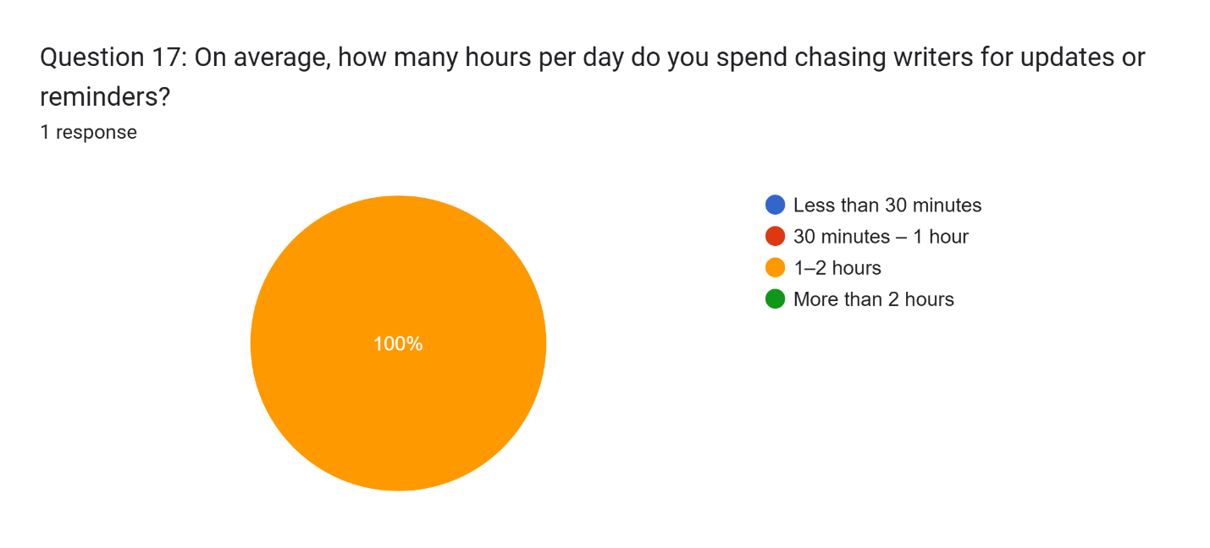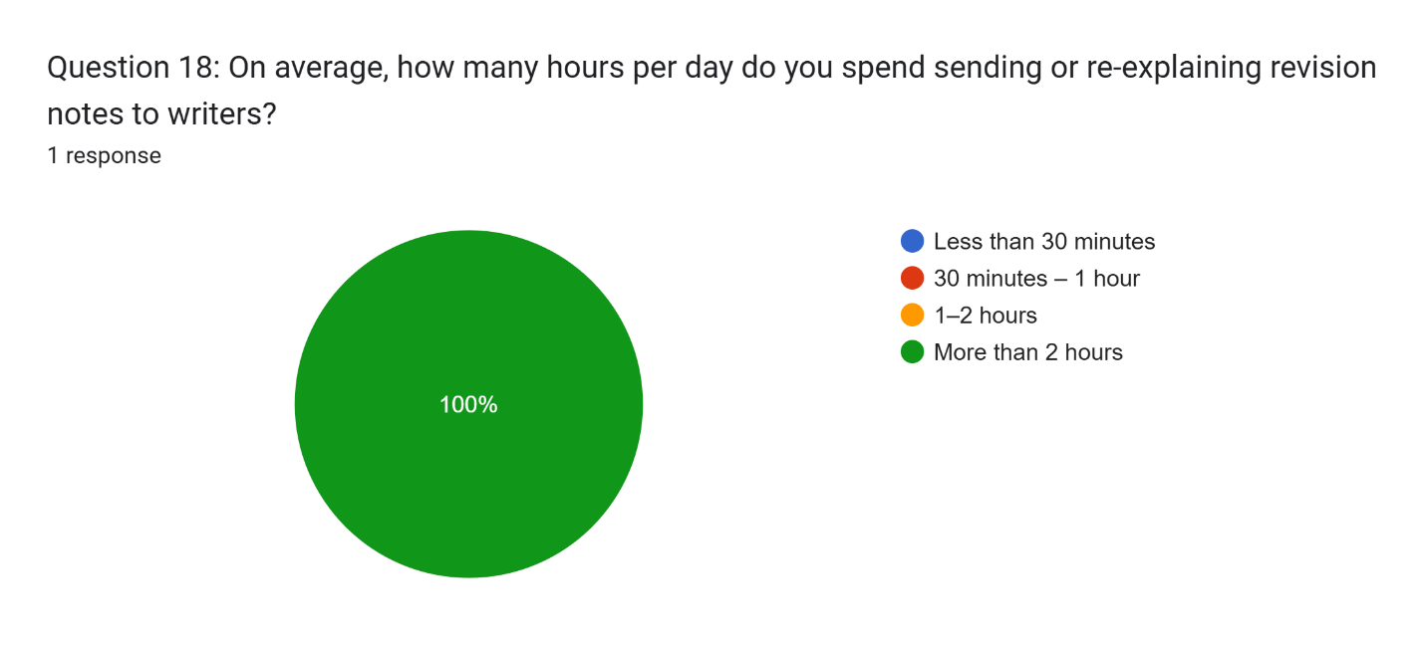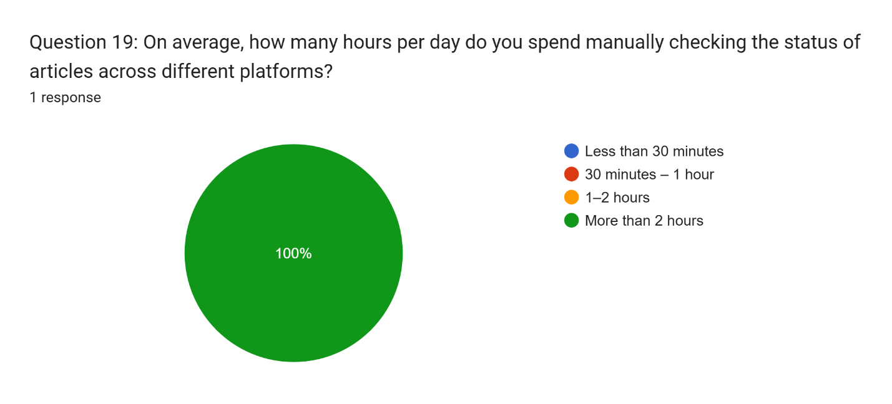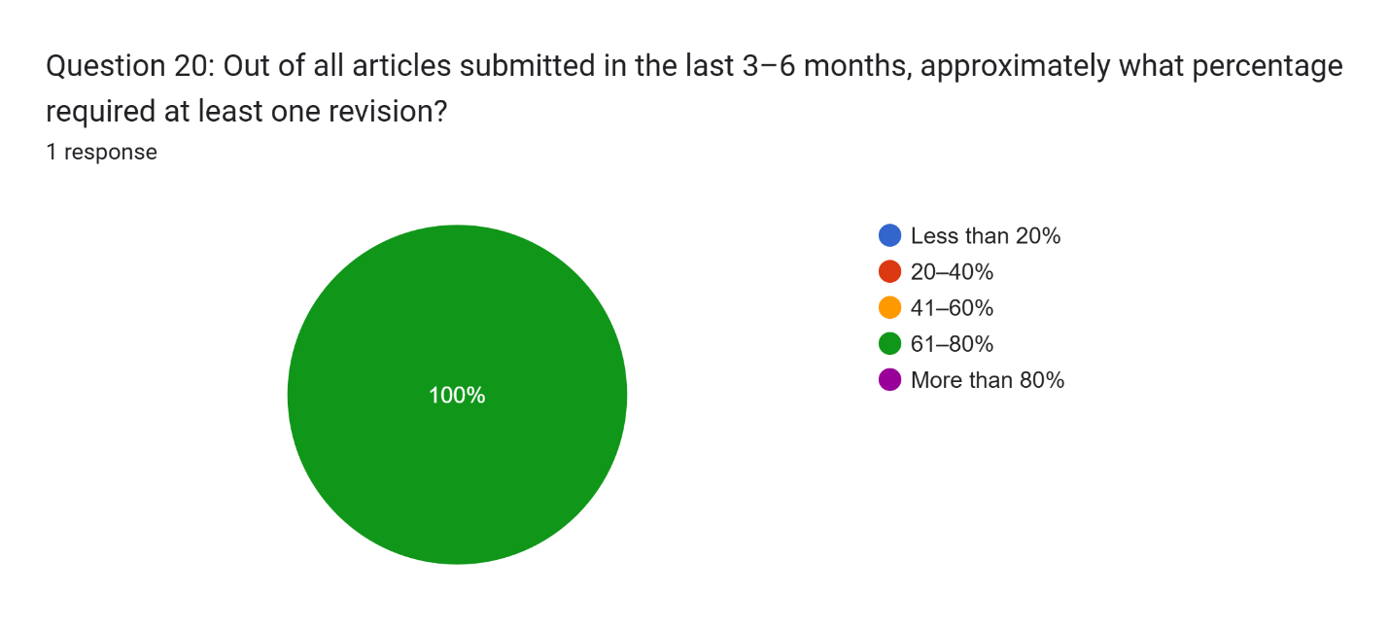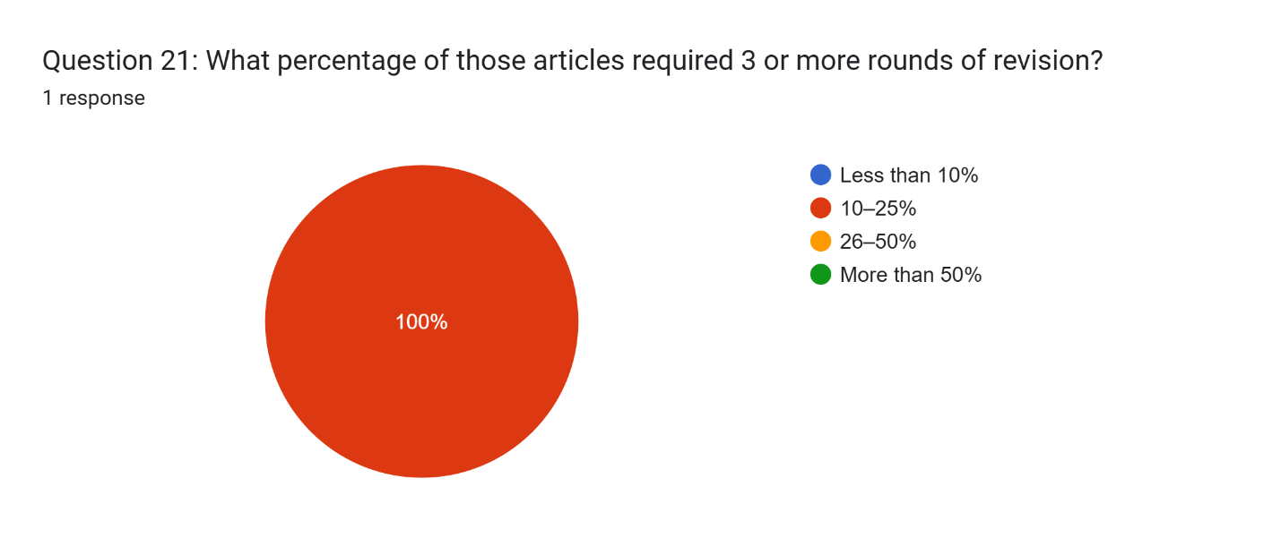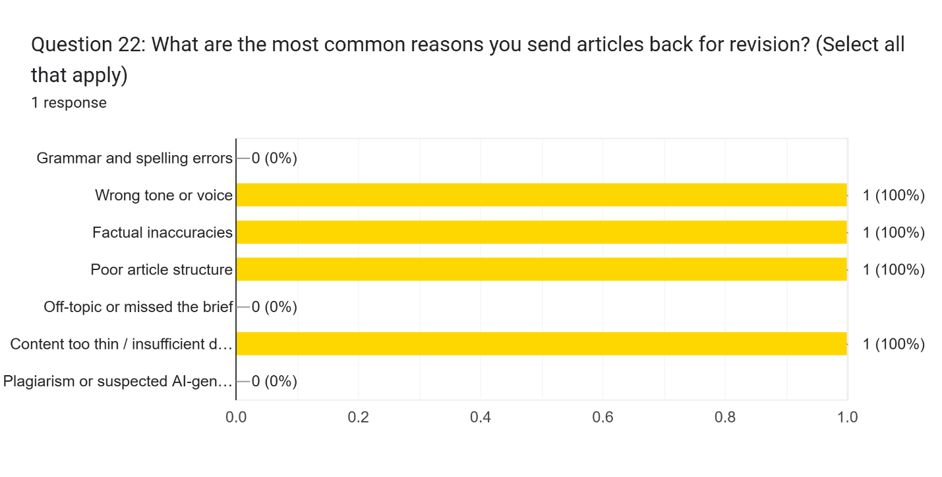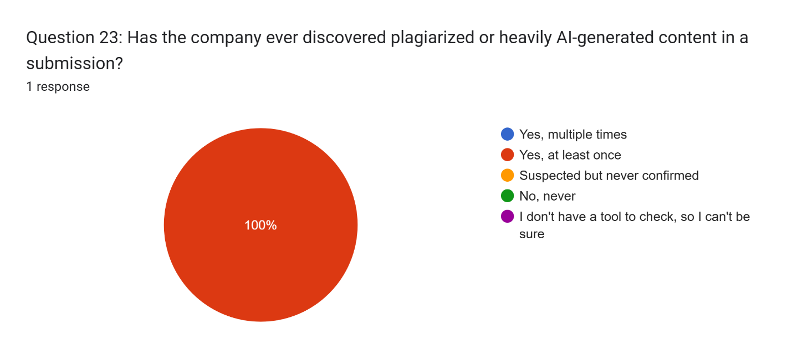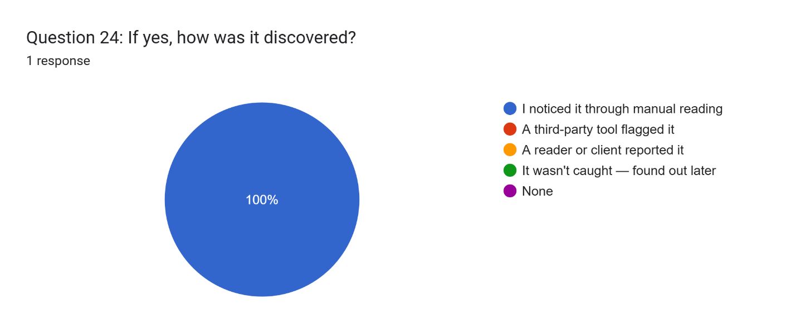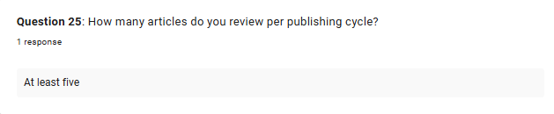
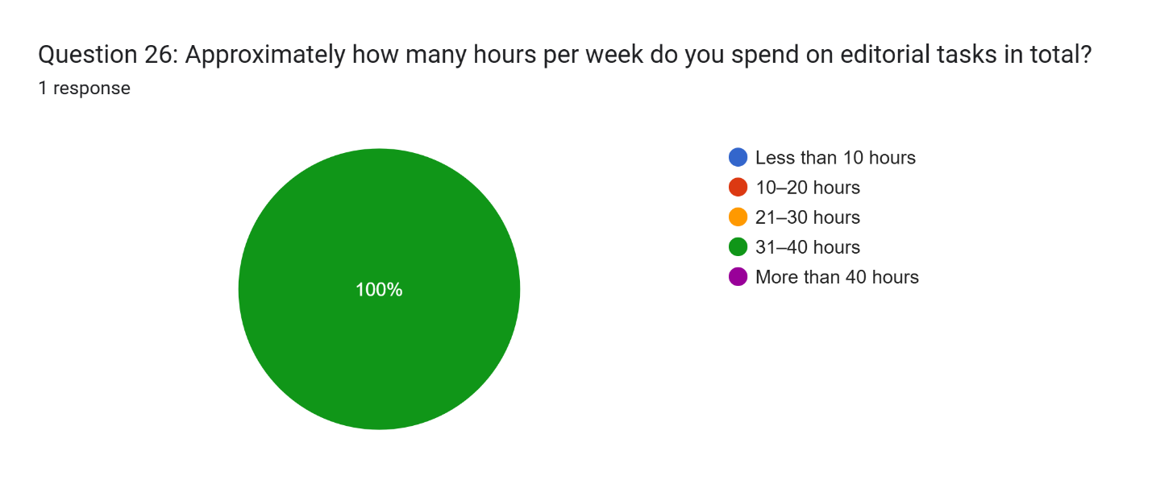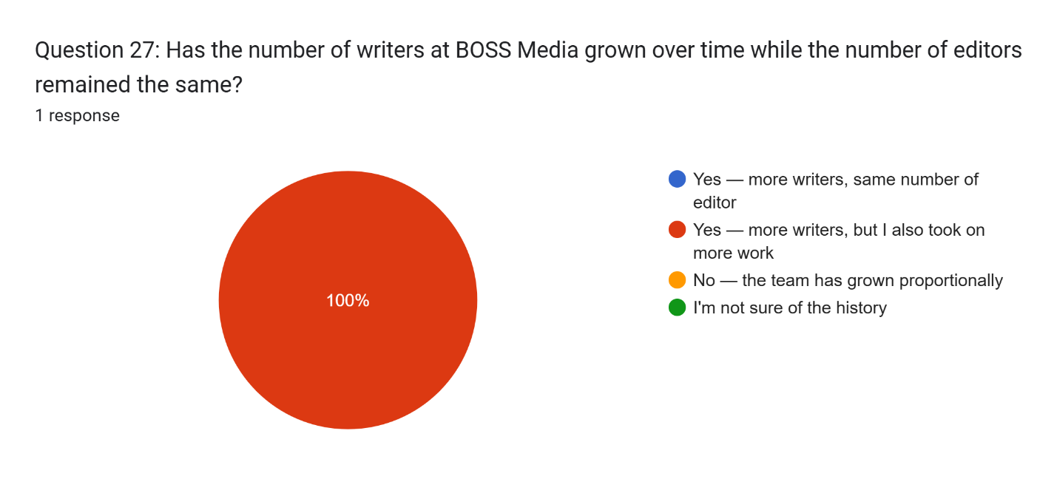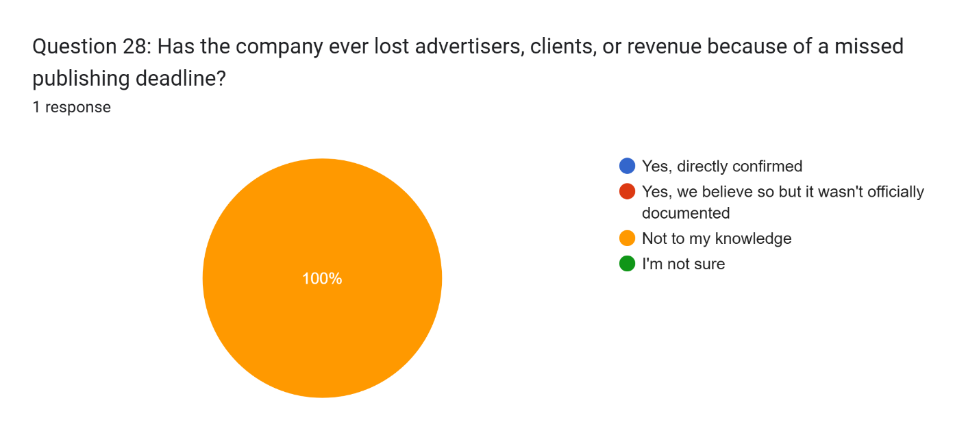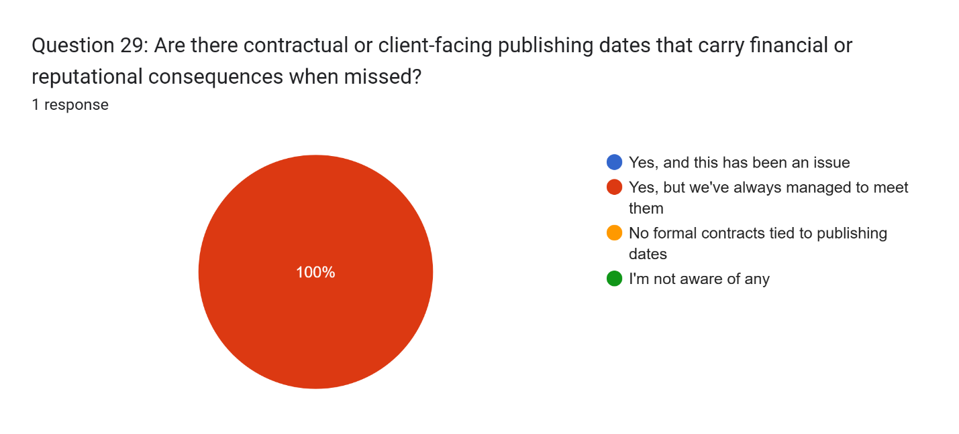

Appendix I: Final Defense Comment Matrix
1. General & System Logic
Category | Panel Comment / Question | Action Required / Proposed Resolution | Status
Performance | Look into other performance indicators to measure, such as productivity. “How will you be able to measure this?” | Define additional productivity metrics and outline the exact methodology for measuring them. | ⏳ Pending
Business Model | Focus more on the revenue stream because there is an associated cost that comes with it. | Detail the revenue model explicitly and align it with the operational/infrastructure costs. | ⏳ Pending
Scope | The solution was too spread out. | Narrow the focus or better articulate the integration of the system components to show cohesive design. | ⏳ Pending
Change Mgmt. | There was no mention of users being trained on the solution. Add training as part of the changes that the writers will undergo. | Include a "User Training/Onboarding" section in the deployment or implementation plan for writers. | ⏳ Pending
Competitors | Why not use Grammarly instead of building your own tool? (Tool justification). | Formulate a strong comparative analysis matrix showing features your system provides that Grammarly lacks. | ⏳ Pending

2. AI Features & Metrics
Category | Panel Comment / Question | Action Required / Proposed Resolution | Status
Value Prop. | AI scoring currently seems to have no use. It needs to have a big impact. Relying entirely on the editor means that the AI is redundant. | Redefine the AI’s role—ensure it acts as an essential automation or decision-support tool rather than an optional feature. | ⏳ Pending
Metrics Computation | How was the brand alignment score computed? Do you know how these metrics are computed? | Write down the exact mathematical formulas or algorithmic logic used to calculate all system metrics. | ⏳ Pending
Feature Selection | Why did you choose lexical diversity? | Provide technical justification (with academic/industry sources) for why lexical diversity is relevant to your system. | ⏳ Pending
Edge Cases | Can an excellent article be given a low score? | Define false positive/negative scenarios and explain how the system handles or mitigates these anomalies. | ⏳ Pending
Evaluation Criteria | What is the basis for determining if an article is better? | Establish clear, objective grading rubrics or parameters used by the system to evaluate text quality. | ⏳ Pending

3. Project Objectives
Target Objective | Panel Comment / Question | Action Required / Proposed Resolution | Status
Objective #1 | What is the basis for the target of 50 articles per month? Establish a minimum timeline of 50 articles. In the future, target more than 50. | Provide baseline data (e.g., current manual output) justifying the 50-article target, and rephrase to show future scalability. | ⏳ Pending
Objective #2 | How did you come up with the 45-minute timeframe for article reviews? What happens if we are unable to achieve the 5-minute reduction? Avoid overpromising. | Provide a time-study justification for the 45 minutes. Adjust the target wording to mitigate risk if the reduction isn't met. | ⏳ Pending
Objective #3 (Tech) | When targeting Google Lighthouse, why are we not setting exact targets? Do not leave it open-ended. | Update the objective to include explicit performance scores (e.g., "Achieve a Google Lighthouse Performance score of 90+"). | ⏳ Pending

4. Architecture & Wireframes (Tech Stack)
Component | Panel Comment / Question | Action Required / Proposed Resolution | Status
Database | Why do you need 4 databases? Use 1 database instead. Having both will double the cost. | Consolidate the data architecture into a single database instance to reduce cost and complexity. | ⏳ Pending
LLM / AI | Why do you need both AIs? Having both will double the cost. You can train either Claude or Gemini instead of using both. | Standardize on a single AI provider (either Claude or Gemini) and detail the fine-tuning/prompt engineering strategy for it. | ⏳ Pending

Appendix J: Brand Tone Survey
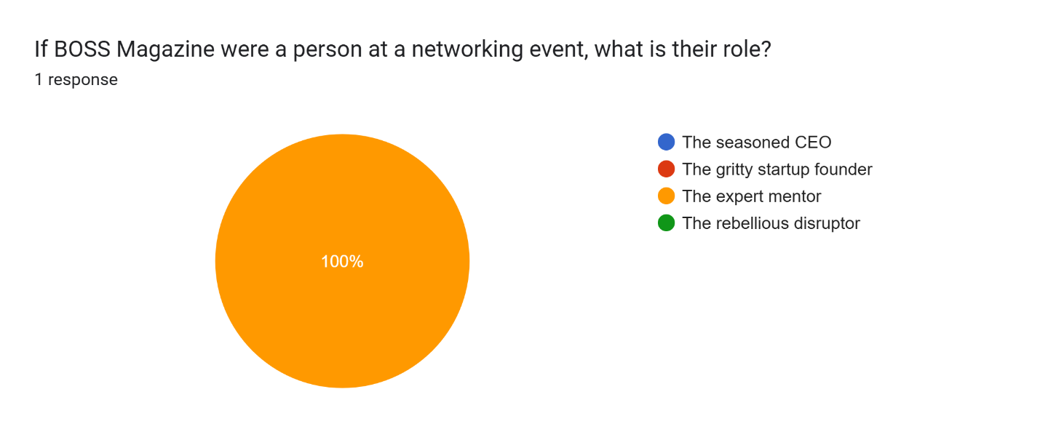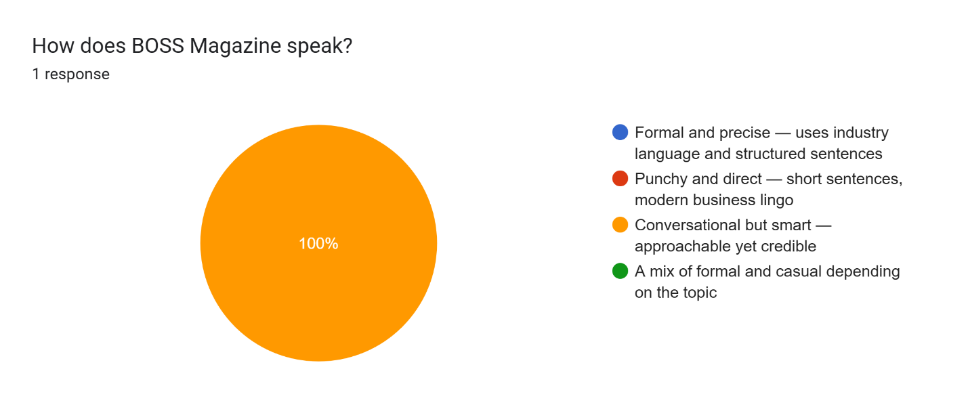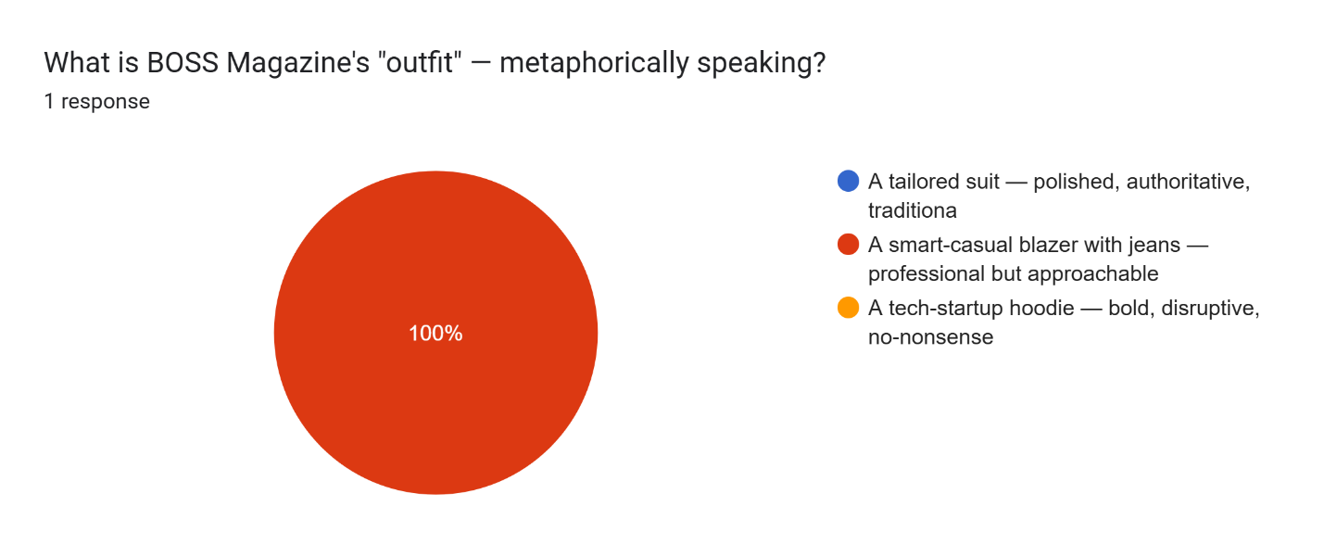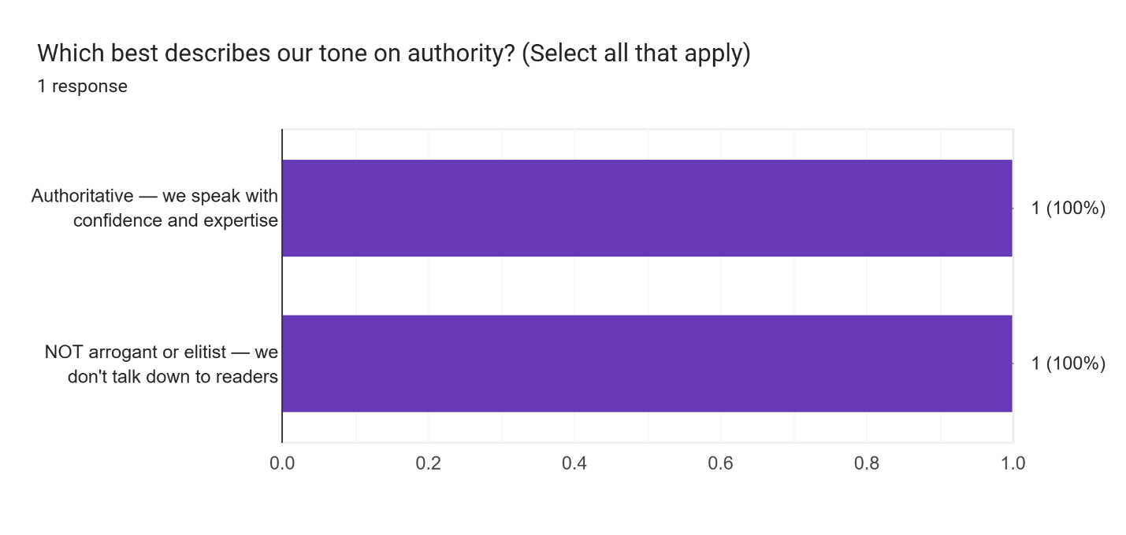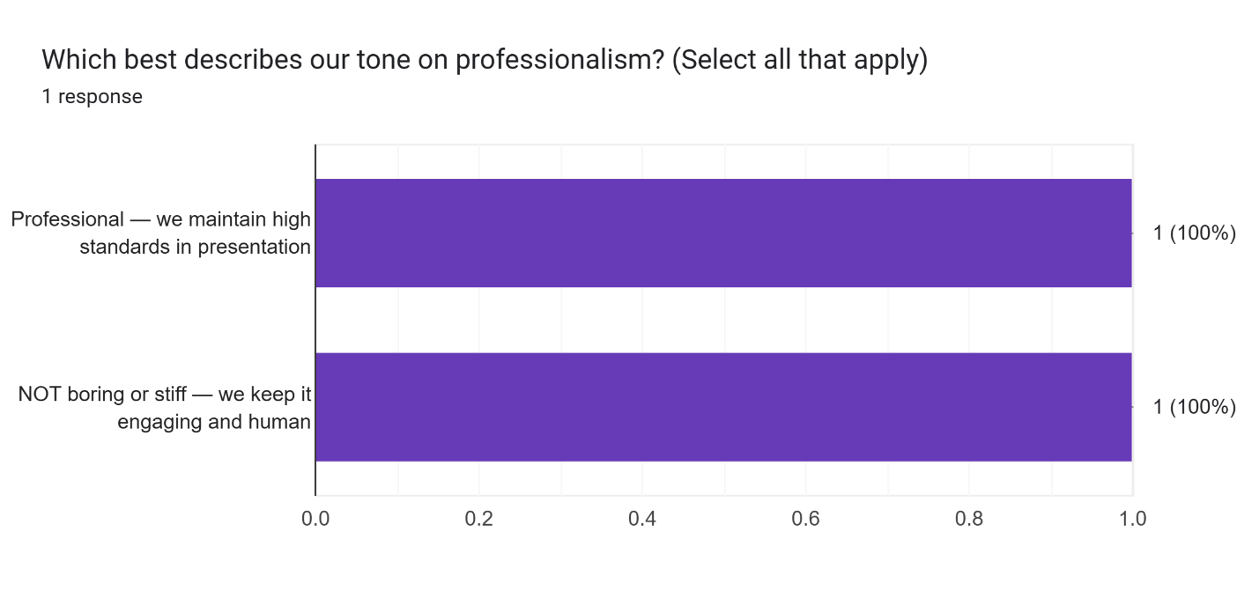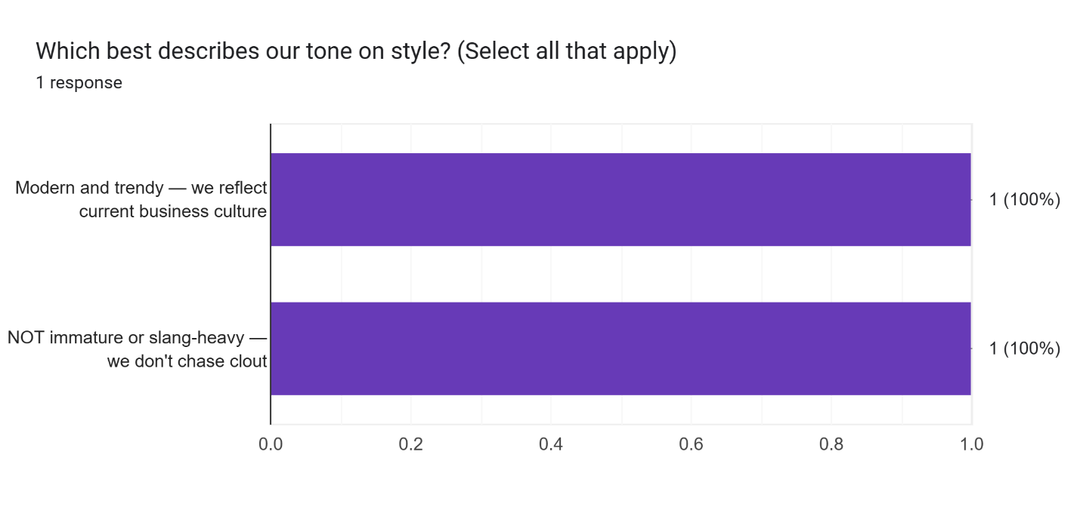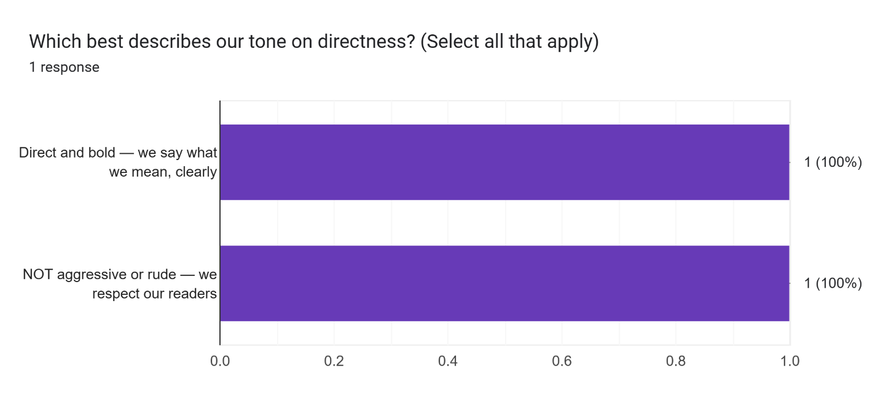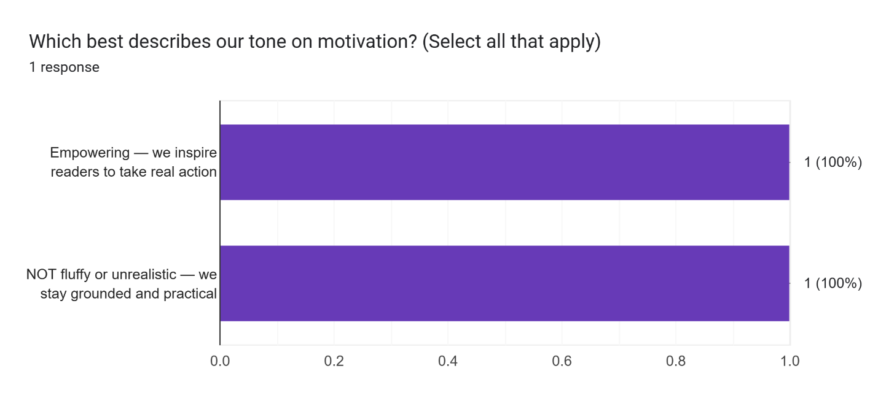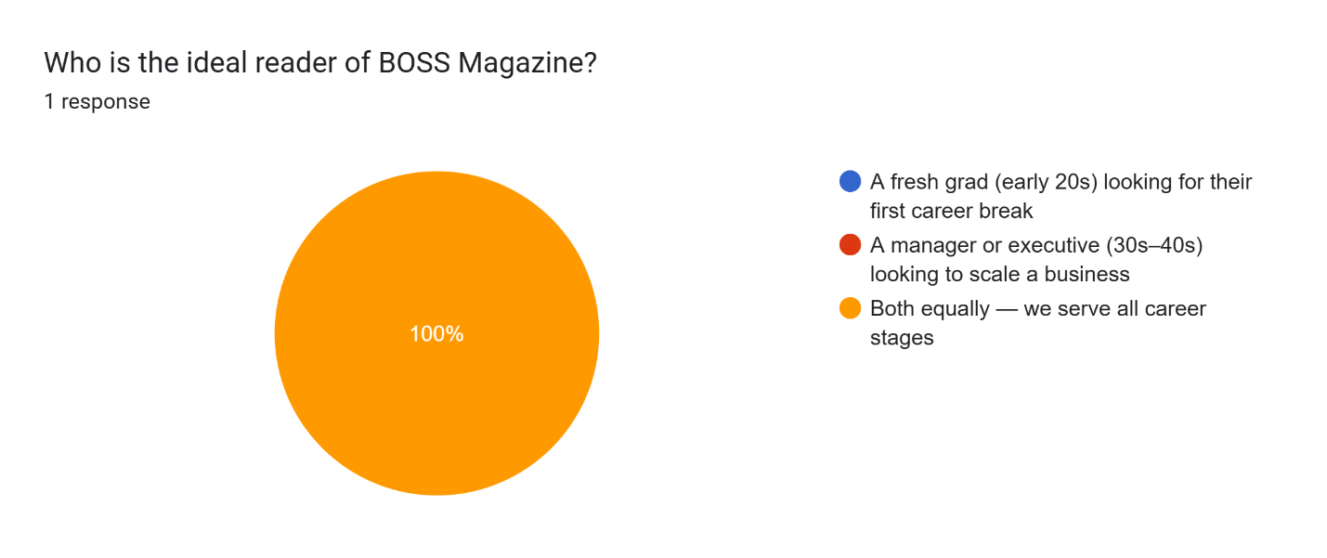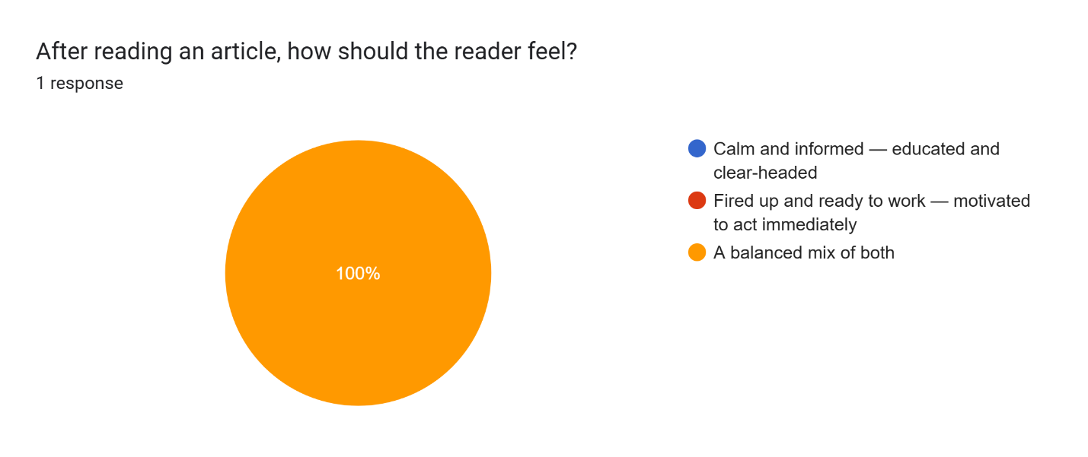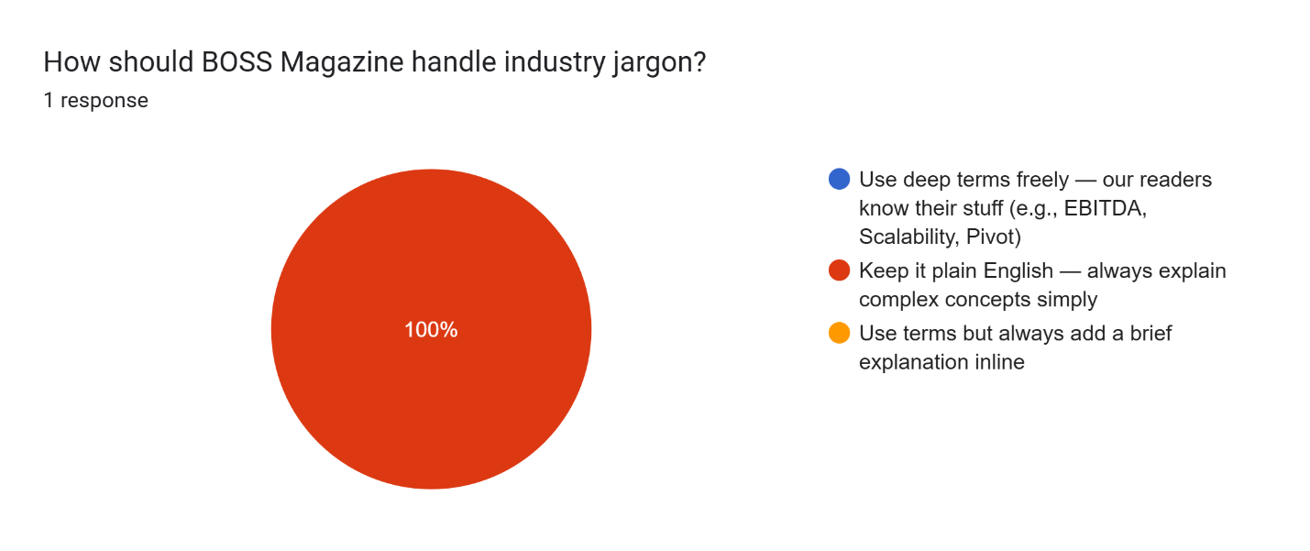

Appendix K: Midterm Comment Matrix
Category | Panelist Feedback / Issue | Action Plan / Implementation Strategy | Status
Objectives | Simplify and unify project objectives to avoid confusion; use consistent metrics. | Rewrote objectives into a structured manner. Defined exact targets (e.g., 50 articles/month, 45 to 5-minute workload reductions) without methodology buzzwords. | ✅ Implemented
Objectives | Clarify timeline terminology by avoiding specific academic terms. | Removed internal academic course jargon and updated all final timeline milestones across the documentation to uniformly read "by the end of the first iteration". | ✅ Implemented
System Logic | Centralize tracking for all submission states (new, revised, rejected). | Designed and documented a visual, stage-based editorial pipeline tracking system within the application dashboard to trace all article lifecycle changes centrally. | ✅ Implemented
System Logic | Consolidate fragmented notification channels and handle missed deadlines. | Built a "Dual-Channel Notification Protocol" separating internal Firebase push alerts from external API-driven transactional emails. | ✅ Implemented
System Logic | Implement formal version control and workflow roles. | Developed Role-Based Access Control (RBAC) tied to database security rules and implemented "Centralized Version Control" for article revisions. | ✅ Implemented
System Logic | Define the criteria for the AI-assisted "Brand Alignment Score". | Established a 100-point algorithmic rubric incorporating Flesch Reading Ease (40-50), Lexical Diversity (0.5-0.6), and grammatical/typographical proofreading thresholds. | ✅ Implemented
Architecture | Justify the use of Gemini AI combined with RAG. | Documented the model strategy: Gemini 4.7 for semantic reasoning/grammar, and RAG-based reader discovery with direct citations. | ✅ Implemented
Architecture | Verify AI output correctness and handle API system limits. | Authored an "AI Risk Management" protocol detailing server-side message queues, token caching, deterministic algorithm anchoring, and graceful degradation fallbacks. | ✅ Implemented
Architecture | Formally justify the choice of cloud infrastructure. | Justified the migration to Railway (PaaS) within the Economic Feasibility and RRL to eliminate cross-provider network egress latency and stabilize costs. | ✅ Implemented
System Logic | Ensure auditability of who made what changes and when across the workflow pipeline. | Integrated MongoDB into the polyglot persistence model to act exclusively as an immutable NoSQL audit trail for all system logs and AI API prompts. | ✅ Implemented
Strategy | Prove that the system (Novus AI) effectively reduces editorial workload and delays. | Defined baseline manual metrics (45 mins) vs. projected system metrics (5 mins) and outlined a User Acceptance Testing (UAT) verification plan using chronometry and NASA-TLX. | ✅ Implemented
Version Control | Implement formal version control for all article revisions to prevent data loss. | Integrated Centralized Version Control within the Unified Editorial Dashboard to track delta changes and history. | ✅ Implemented
Strategy | Ensure the primary focus remains a Content Management System (CMS). | Aligned core sprints around CMS functionality. Formally updated the UML Use Case architecture to integrate the backend System Administrator role running a centralized Platform Control Plane (handling global configurations, API metrics, and audit log analysis). | ✅ Implemented
Strategy | Evaluate public-facing accessibility channels. | Map out a preliminary feasibility study or conceptual design for a future public-facing mobile application companion. | ❌ Rejected

Appendix L: Statement of work



Asia Pacific College

Statement of Work

Academic Project Agreement

Version 3.0

Presented by:

Time and materials

Company Name | BOSS MAGAZINE PH
Company Administrator | Remie Degoma
Company POC | Primary POC:  Remie Degoma  Alternate POC:  NA
APC POC | Primary POC:  Joshmar Clavero  Alternate POC:  Rei Khalil Galido  Roman Rico Albania
Project Name | Novus: Smart Editorial & Publishing Platform
Engagement Duration | One term, renewable
Begin Date | March
End Date | June 2026

Schedule of rates and Payment terms (NA)
The project is undertaken by student team, guided by their professor in fulfilment of their academic requirements. The professional service is at no cost to the client, Remie Degoma. However, the company may provide for logistical costs and other expenses at their discretion.

Statement of work

Assumptions

Asia Pacific College provides students opportunities to work with real industry projects as an part of the fulfilment of their academic requirements. Graduating/Senior/Junior students attending the courses on MNTSDEV are assigned as project teams to perform academic services to develop the – NOVUS: Smart Editorial & Publishing Platform
Students assigned to the project are as follows: Name of Students
Professor Carl Dominique Bueno acts as mentor and facilitator throughout the project undertaking.

Asia Pacific College provides access to development platform, specifically programming language/framework as well as hardware necessary to develop the system. Also provided are project laboratory complete with required hardware and other equipment.
Mrs. Remie Degoma provides student team with user requirement, specifically, business processes required to enable fulfilment of purposes of the Smart Editorial & Publishing Platform; thus, enabling Mrs. Degoma to utilize a performance management framework to capture and document project implementation, enable effective and efficient discharge of organizational roles and responsibilities towards achievement of their business objectives and mission.

Data Privacy Policy

Both Boss Magazine PH and APC shall abide by the Data Privacy Act of 2012, all its Implementing Rules & Regulations. Data from either party and that of the students shall be protected and used only within the terms and conditions of the SOW and its corresponding MOA. Any breech by either party in the agreement pertaining to data.

Change management process
Throughout the development process, consultations with stakeholders will take place. Meetings and submission of outputs are venues for stakeholders to be informed of developments and participate by continually contributing to refinement of processes and systems review and innovation should the need arise. There will be three (3) to four (4) iterations throughout the systems development process.

Engagement related expenses (NA)
Company may opt to provide for related expenses such as maintenance and operating costs which may include transportation cost during meetings at client site, supplies and materials and communications. However, this is not required of the client.

Academic services agreement
Annex for the Work Breakdown Structure (WBS) for the projects. This documents will guide project implementation and accountability. The WBS identifies schedule and assignment of tasks to team members as well as roles of the client, specifically articulation of client requirement, approval of plan and accomplishment of client feedback form.

Acceptance and authorization

The terms and conditions of the Academic Project Agreement apply in full to the services and products provided under this Statement of Work.
IN WITNESS WHEREOF, the parties hereto each acting with proper authority have executed this Statement of Work, under seal.

REMIE DEGOMA |  | JOSHMAR CLAVERO
^{Full name} |  | ^{Full name}
REPRESENTATIVE/CHIEF |  | TEAM MEMBER
^{Designation} |  | ^{Designation}
 |  | 
^{Signature} |  | ^{Signature}
APRIL 11, 2026 |  | APRIL 11, 2026
^{Date} |  | ^{Date}

